Linux tasks List

- Create user with name Techie and provide sudo access to user.
- Navigate to the home directory.
- Create a new directory.
- List the contents of a directory.
- Change the current directory.
- Create a new empty file.
- View the contents of a file.
- Copy a file to another location.
- Move a file to another location.
- Rename a file.
- Delete a file.
- Grant or revoke permissions on a file or directory.
- View the current date and time.
- Check the system uptime.
- View the running processes.
- Kill a running process.
- Install a package using the package manager (e.g., apt or yum).
- Update the system packages.
- Create a symbolic link.
- Search for files using the find command.
- Compress and decompress files using tar.
- Monitor system resources with top or htop.
- Create and manage user groups.
- Set up SSH password less authentication.
- Monitor log files using tail or grep.
- Set up a web server (e.g., Apache or Nginx).
- Configure and secure a MySQL Database.
- Set up a Application Server (e.g.,Apache Tomcat).
- create a service file for Apache Tomcat.(Should execute by using systemtctl command).
- Print specific columns from a delimited file.
- Filter and print lines based on a specific pattern or condition.
- Calculate and print the average, sum, or other statistics of a column.
- Perform string manipulation, such as extracting substrings or changing case.
- Count the occurrences of a specific pattern in a file.
- Sort lines based on a specific field or column.
- Merge multiple files based on a common field or column.
- Substitute text in a file using search and replace.
- Delete specific lines based on a pattern or line number.
- Append or insert text before or after a specific pattern or line.
- Print only specific lines from a file.
- Copy file from linux to windows machine.
- 5 use cases for AWK and 5 use cases for sed.

Task1: Create user with name Techie and provide sudo access to user

Outcome:

A Linux user named Techie is created successfully and is granted sudo privileges to execute administrative commands with elevated permissions.

Objective:

To create a new Linux user named Techie and grant sudo access so the user can perform administrative tasks, such as installing packages, managing services, and modifying system configurations, without logging in directly as the root user.

Prerequisites:

- A Linux system (Ubuntu or Debian recommended).
- Access to a terminal.
- An existing user account with sudo privileges or root access.
- Internet access if additional packages are required.
- Basic knowledge of Linux commands.

Step-by-Step Implementation:

Step 1: Open the terminal.

Navigation Path:

On Ubuntu, use the keyboard shortcut Ctrl + Alt + T to open the terminal. Or right Click then Select Open Terminal.

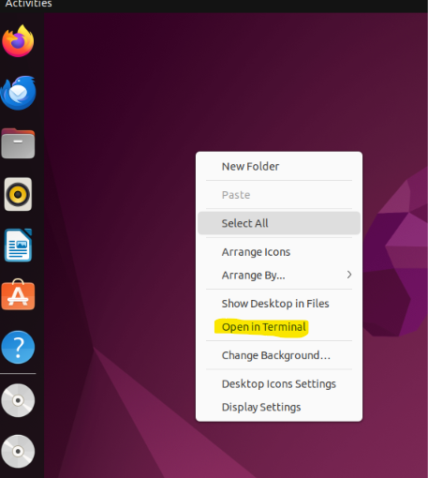

Check the current user where we know the from which user we are running the commands. For that we have a command called whoami will give the current user name.

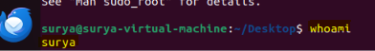

Check the current Linux distribution for this we have a command called cat /etc/os-release gives the Linux distribution name.

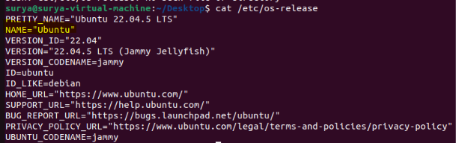

Step 2: Create the User Techie.

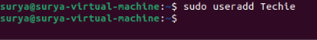

Command explanation:
sudo: executes the command with administrative privileges.
useradd: creates a new user in linux
Techie: user name

Check the user is created or not we have a command called cat /etc/passwd | grep “Techie” /etc/passwd which will give all users in the machine.

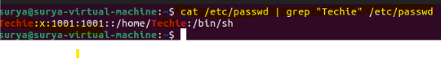
Command explanation:
cat: Used to read the content in the file.
/etc/passwd: Here etc is the directory and passwd is the file where we have to find all the users names.
|(Pipe): Pipe is used to give the output of the cat command is given input to the grep command.
grep: When we run only cat command we will get lot of user names so difficult to find our username so adding grep we can search our username So only Techie username will show.

Step 3: Grant Sudo Access to Techie.

Execute the following command to add the user to the sudo group.

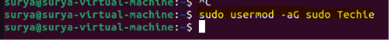

Verify the group membership

Command Explanation

Usermod: Modifies an existing user account.
-a: Appends the user to supplementary groups without removing existing memberships.
-G sudo: Adds the user to the sudo group.
Techie: Specifies the target user.

Step 4: Switch to the Techie User

Execute the following command to switch the user to Techie.

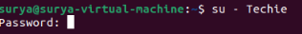

Enter the password for Techie user

Verify the current username

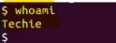

Step 5: Verify Sudo Access.

While logged in as Techie, execute:
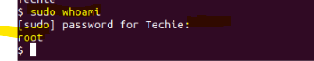

This confirms that the user can execute this administrative command with elevated privileges.

You can also test access by running:

sudo apt update

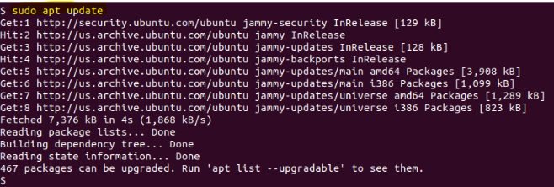

This refreshes package lists on Ubuntu and may take some time. It is optional for validating sudo access.

Validation Steps:

Students must verify that the user exists, belongs to the sudo group, and can execute commands through sudo.
Run these checks from an account with appropriate permissions, or from the Techie account where applicable.

Validation | Command | Expected Result
User exists | Id Techie | 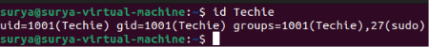
Sudo group membership | groups Techie | 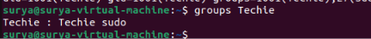
Current Logged in user | whoami | 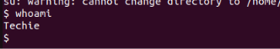
Sudo access | Sudo whoami | 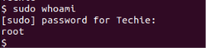

Explanation:

A Linux user named Techie was created using the useradd command. A separate user account helps maintain individual access and accountability instead of requiring routine work through the root account.
Sudo privileges were granted by adding Techie to the sudo group. This allows the user to execute authorized administrative commands when needed. The sudo whoami command was used to verify the configuration because it runs whoami with elevated privileges and returns root. Sudo access should be granted only to trusted users because it allows significant control over the system.

Real-Time Use Case:

In an IT organization, a system administrator may create individual Linux accounts for engineers who need to maintain servers. The user Techie could install approved software, restart services, update packages, and troubleshoot system issues through sudo without sharing the root password.
This approach supports user accountability, access management, and the principle of least privilege when combined with appropriate sudo policies.

Common Errors and Troubleshooting:

Error | Possible Cause | Resolution
adduser: The user 'Techie' already exists | The username is already present. | Verify with id Techie and reuse the existing account if appropriate.
Permission denied | The current account lacks administrative privileges. | Log in with an authorized sudo account or root account.
user is not in the sudoers file | The user lacks sudo authorization or group changes have not taken effect. | Verify groups Techie, correct the group membership, and start a new login session.
sudo: command not found | Sudo may not be installed on a minimal Linux system. | As root, install the sudo package using the distribution's package manager.
Incorrect password | The entered password does not match the user's password. | Retry carefully or reset the password using an authorized administrator account.
usermod command fails | Incorrect syntax or insufficient permissions. | Check the command and run it with administrative privileges.

Task2: Navigate to the home directory.

Outcome:

Successfully open Ubuntu Linux in VMware, launch the Terminal, and navigate to the user's home directory.

Objective:

To learn how to access the Ubuntu terminal and use Linux commands to navigate to the home directory.

Prerequisites:

- VMware Workstation or VMware Player installed.
- Ubuntu Linux virtual machine created.
- Ubuntu virtual machine powered on.
- User credentials to log in to Ubuntu.

Step-by-Step Implementation:

Step 1: Open the Terminal:

Open the Ubuntu terminal using one of the following methods:
- ctrl + alt + T. or
- Right click and select the open terminal.
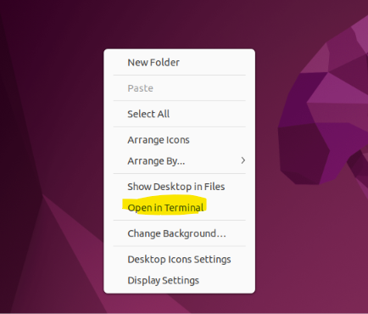

Terminal Opened:

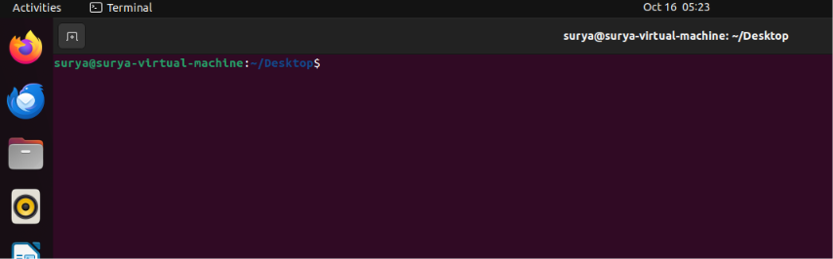

Step 2: Navigate to the Home Directory:

Type the following command in the Ubuntu terminal and press Enter.

Cd ~

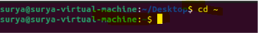

This command navigates to the home directory of the currently logged-in Ubuntu user.

Step 3: Verify the Home Directory:

Execute the following command
pwd

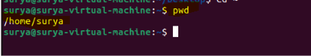

This command shows the current directory of the currently logged-in Ubuntu user.

By using echo $HOME this command also we get the present working directory.



Validation Steps:

Verify that the terminal is currently in the home directory.

By using below commnads

- pwd.

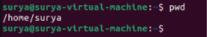

- echo $HOME

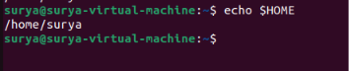

Explanation:

The home directory is the personal working directory assigned to each user in Ubuntu Linux. It is commonly located under /home/username, while the root user's home directory is /root.
The cd ~ command navigates directly to the current user's home directory. The pwd command displays the present working directory, helping users verify their location in the Linux filesystem.

Real-Time Use Case:

In real-world environments, Linux administrators and developers frequently navigate to their home directories to access scripts, configuration files, downloaded resources, and project folders. For example, a developer may navigate to the home directory before creating a project folder or running a shell script.

Common Errors and Troubleshooting:

Error or Issue | Cause | Resolution
cd: command not found | The shell environment or command entry is incorrect. | Check the command spelling and terminal environment.
Unexpected directory shown by pwd | The navigation command was not executed successfully or another command changed the directory. | Run cd ~ again, then execute pwd.
Home directory path is unexpected | The account has a nonstandard home directory configuration. | Run echo $HOME to check the configured home directory.
Permission denied when accessing a file | The user lacks permission to access that file or directory. | Check permissions using ls -l and access the correct directory.

Task 3: Create a new directory.

Outcome:

A new directory named Tasks is successfully created in the Ubuntu Linux home directory.
/home/surya/Desktop/Tasks.

Objective:

To learn how to create a new directory in Ubuntu Linux using the mkdir command and understand basic directory management in the Linux filesystem.

Prerequisites:

- Ubuntu Linux operating system.
- Ubuntu desktop running and accessible.
- Logged in to the Ubuntu desktop.
- Access to the Ubuntu terminal.

Step-by-Step Implementation:

Step 1: Open Ubuntu

- Start your Ubuntu operating system.
- Log in using your Ubuntu username and password, if prompted.



3. Wait for the Ubuntu desktop to appear.

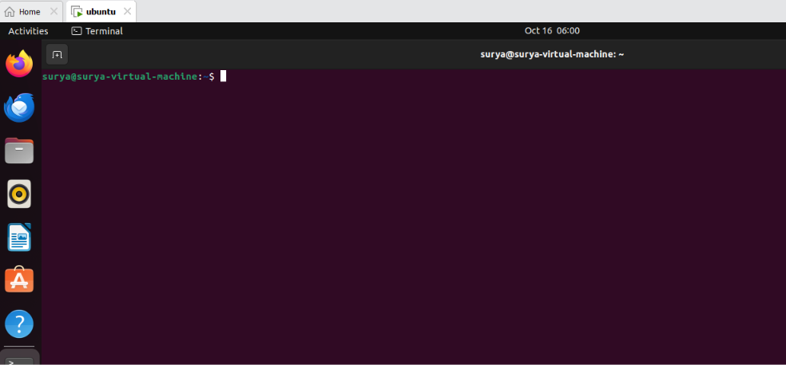

Step 2: Open the Ubuntu Terminal

Press the following keyboard shortcut:
Ctrl + Alt + T

Alternatively, right click and click on open Terminal.

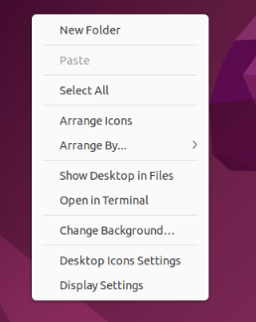

Step 3: Navigate to the Home Directory

Execute the following command:
cd ~

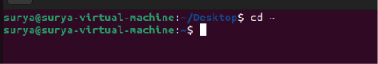

Verify your current location:

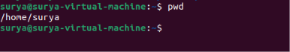

Step 4: Create a New Directory

Execute the following command to create a directory named Tasks:
mkdir Tasks

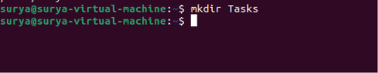

Explanation:

mkdir stands for make directory.
Tasks is the name of the new directory.
The directory will be created in the current working directory.

Step 5: Verify the Directory Creation

Run the following command to list the contents of the home directory:
ls

To confirm the directory's full path, execute:

ls -ld ~/Tasks

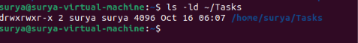

Validation Steps

Verify that the directory exists by running:
test -d ~/Tasks&& echo "Directory created successfully"

Explanation

In Ubuntu Linux, directories are used to organize files and other directories. The mkdir command creates a new directory at the specified location. When you execute mkdir Tasks from your home directory, Linux creates the folder inside that directory.
The ls command displays directory contents, while ls -ld displays information about the specified directory itself. These commands help verify that the new directory was created successfully.

Real-Time Use Case

Linux administrators and developers create directories to organize projects, scripts, configuration files, logs, and backups. For example, a developer may create a project directory in the home directory to keep application files organized.

Common Errors and Troubleshooting:

Error or Issue | Cause | Resolution
File exists | A directory or file named Tasks already exists. | Use ls to check, or choose another directory name.
Permission denied | The user does not have permission to create a directory at the selected location. | Navigate to your home directory using cd ~ and retry.
No such file or directory | The specified parent directory does not exist. | Verify the path using pwd and ls.
Directory not visible in ls | The command may have been executed in another location. | Run pwd to check the current directory.

Task 4: List the contents of a directory.

Outcome:

Successfully list the files and directories available in the home directory using Ubuntu Linux terminal commands.
The terminal displays the files and directories present in the specified location.

Objective:

To learn how to view the contents of a directory in Ubuntu Linux using the ls command and understand how to identify files and subdirectories.

Prerequisites:

- Ubuntu Linux operating system.
- Logged in to the Ubuntu desktop.
- Access to the Ubuntu terminal.
- A home directory containing files or directories.

Step-by-Step Implementation

Step 1: Open Ubuntu Terminal

Open the Terminal by pressing the following keyboard shortcut:
Ctrl + Alt + T

Alternatively, right click and click open in Terminal

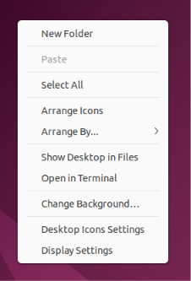
Step 2: Navigate to the Home Directory

Execute the following command:
cd ~

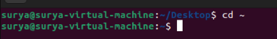

Verify the current working directory:
pwd

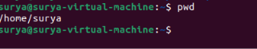

Step 3: List the Contents of the Directory

Execute the following command:
ls

This command displays the names of files and directories in the current directory.
Example output:
Desktop Documents Downloads Music Pictures Public Templates Videos MyDirectory

Your output may differ depending on the files and directories present in your home directory.

Step 4: List All Contents, Including Hidden Files

Execute the following command:
ls -a

The -a option displays all entries, including hidden files and directories whose names begin with a dot (.).
Example output:
. .. .bashrc .profile Desktop Documents Downloads MyDirectory

- . represents the current directory.
- .. represents the parent directory.

Step 5: Display Detailed Directory Information

Execute the following command:
ls -l

This command displays detailed information about each listed entry, including permissions, ownership, size, modification date, and name.
Example output:
drwxr-xr-x 2 ubuntu ubuntu 4096 Oct 16 10:30 MyDirectory

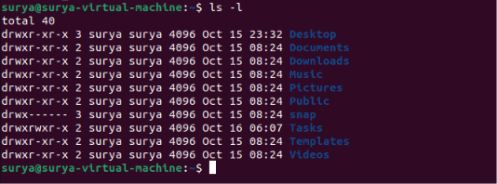

Validation Steps

Run the following commands to verify that directory listing works correctly:
cd ~
ls
ls -a
ls -l
Confirm that:
-ls displays visible files and directories.

ls -a includes hidden entries.

ls -l displays detailed information about the entries.

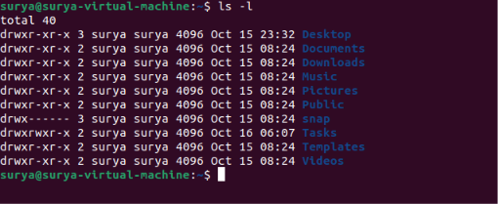

Explanation:

In Ubuntu Linux, the ls command is used to list the contents of a directory. It helps users identify available files and folders without opening each one individually. By default, ls does not display hidden files, which generally have names beginning with a dot.
The command supports several useful options. ls -a displays hidden entries, while ls -l displays detailed file information. These options help users inspect the filesystem and manage files more efficiently.

Real-Time Use Case:

Linux administrators and developers use directory listing commands to inspect project files, locate configuration files, check downloaded documents, and review server directories. For example, an administrator can use ls -l to inspect file permissions and ownership when troubleshooting access issues.

Common Errors and Troubleshooting:

Error or Issue | Cause | Resolution
ls: cannot access | The specified directory or file does not exist. | Check the path and spelling
No files displayed | The directory may be empty or contain only hidden files. | Run ls -a to include hidden entries.
Permission denied | The user lacks permission to access the specified diretory | Check directory permissions and use an authorized account.
Unexpected files displayed | The terminal is in a different directory. | Run pwd, then navigate using cd ~.

Task 5: Change the current directory.

Outcome:

Successfully change the current working directory in Ubuntu Linux using the cd command and verify the new location using pwd.
The terminal's current working directory changes to the selected directory.

Objective:

To learn how to navigate between directories in Ubuntu Linux using the cd (change directory) command and verify the current working directory.

Prerequisites:

- Ubuntu Linux operating system.
- Logged in to the Ubuntu desktop.
- Access to the Ubuntu terminal.
- A directory available for navigation, such as MyDirectory in the home directory.

Step-by-Step Implementation

Step 1: Open the Ubuntu Terminal

Press the following keyboard shortcut:
Ctrl + Alt + T

Alternatively, right click and click on the open in Terminal

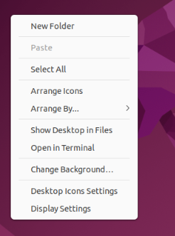
Step 2: Check the Current Directory

Execute the following command:
pwd

Example output:
/home/ubuntu

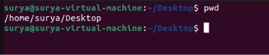

Step 3: Change to Another Directory

Navigate to the Tasks directory created in Task 3 by executing:
cd ~/Tasks

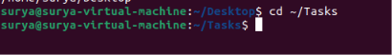

Explanation:
- cd stands for change directory.
- ~ represents the current user's home directory.
- Tasks is the destination directory.

Step 4: Verify the New Current Directory

Execute the following command:
Pwd

Example output:
/home/ubuntu/MyDirectory

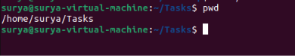

The output confirms that the current working directory has changed successfully.

Step 5: Navigate Back to the Home Directory

Execute the following command:
cd ~

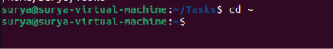

Verify the location:
pwd

Example output:
/home/ubuntu

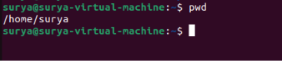

Validation Steps:

Run the following commands to verify directory navigation:
cd ~

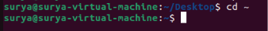

Pwd



cd ~/Tasks

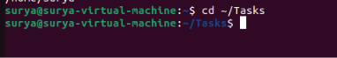

pwd

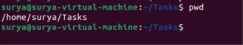

Example output:
/home/ubuntu
/home/ubuntu/Tasks

Explanation:

In Ubuntu Linux, the cd command is used to change the current working directory. It allows users to move between folders without using the graphical file manager. The destination can be specified using an absolute path, a relative path, or the ~ symbol for the home directory.
The pwd command displays the current working directory. Using pwd after cd helps confirm that navigation was successful. Users can also execute cd .. to move to the parent directory or cd ~ to return to their home directory.

Real-Time Use Case:

Linux administrators and developers frequently change directories to access application files, edit configuration files, execute scripts, and inspect logs. For example, a developer can navigate to a project directory before running a program or modifying its source code.

Common Errors and Troubleshooting:

Errors or Issues | Cause | Resolution
No such file or directory | The destination directory does not exist or the path is incorrect. | Check the directory name using ls.
Permission denied | The user lacks permission to access the destination directory. | Check directory permissions and use an authorized account.
Current directory does not change | The command was entered incorrectly. | Re-enter the cd command with the correct path.
Unexpected path displayed | The terminal is in a different location than expected. | Run pwd to check the current directory.

Task 6: Create a new empty file.

Outcome:

Successfully create a new empty file named myfile.txt in the Ubuntu Linux home directory using the terminal.
/home/username/myfile.txt

Objective:

To learn how to create an empty file in Ubuntu Linux using the touch command and verify that the file has been created successfully.

Prerequisites:

- Ubuntu Linux operating system.
- Logged in to the Ubuntu desktop.
- Access to the Ubuntu terminal.
- Basic knowledge of Linux commands, such as cd and pwd.

Step-by-Step Implementation

Step 1: Open the Ubuntu Terminal

Press the following keyboard shortcut:
Ctrl + Alt + T
Alternatively, right click and click on open in Terminal.

Step 2: Navigate to the Home Directory

Execute the following command:
cd ~

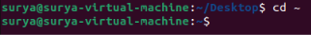

Verify the current working directory:

pwd

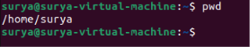

Step 3: Create a New Empty File

Execute the following command:
touch myfile.txt

Explanation:
touch creates a new empty file if the specified file does not exist.
myfile.txt is the name of the file being created.
The file is created in the current working directory.



Step 4: Verify the File Creation

Run the following command to list the directory contents:
ls

Expected output should include:
myfile.txt

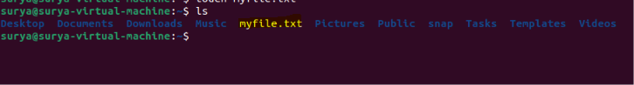

To check the file's details and size, execute:
ls -l myfile.txt

Example output:
-rw-rw-r-- 1 ubuntu ubuntu 0 Oct 16 17:00 myfile.txt

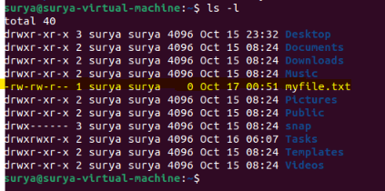

The file size is 0 bytes, confirming that the newly created file is empty. Permissions, ownership, and timestamps may differ on your system.

Validation Steps:

Execute the following command to verify that the file exists and is empty:

test -f ~/myfile.txt && test ! -s ~/myfile.txt && echo "Empty file created successfully"

Expected output:
Empty file created successfully

This command checks that myfile.txt exists as a regular file and has no content.

Explanation:

In Ubuntu Linux, the touch command is commonly used to create an empty file. If the specified file does not exist, the command creates it without adding any content. If the file already exists, touch updates its modification timestamp rather than emptying the file.

The ls command displays the file in the directory listing, while ls -l provides detailed information, including the file size. A size of zero bytes indicates that the file contains no data.

Real-Time Use Case:

Linux administrators and developers create empty files when preparing configuration files, application logs, scripts, and documentation. For example, a developer might create notes.txt before adding project notes or create a placeholder file for a future script.

Common Errors and Troubleshooting:

Errors or Issues | Cause | Resolution
Permission denied | The user lacks permission to create a file in the selected directory. | Navigate to your home directory using cd ~ and retry.
File not visible in ls | The command may have been executed in another directory. | Run pwd and check the correct location.
File already exists | A file with the same name already exists. | Check it using ls -l myfile.txt before proceeding.
File is not empty | The file already contains data. | Choose a new filename to create a fresh empty file.

Task 7: View the contents of a file

Outcome:

Successfully view the contents of a file named myfile.txt in Ubuntu Linux using terminal commands.

The contents of myfile.txt are displayed in the terminal.

Objective:

To learn how to view the contents of a file in Ubuntu Linux using commands such as cat, less, and more.

Prerequisites:

- Ubuntu Linux operating system.
- Logged in to the Ubuntu desktop.
- Access to the Ubuntu terminal.
- A file named myfile.txt created in Task 6.

Step-by-Step Implementation:

Step 1: Navigate to the Home Directory

Execute the following command:
cd ~

Verify the current working directory:
pwd

Expected output (example):
/home/surya

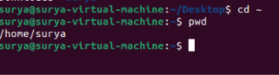

Step 2: Add Content to the File

If you created myfile.txt as an empty file in Task 6, add some sample content before viewing it.

Execute:

vi myfile.txt.

This command opens the editor and add our message into myfile.txt.

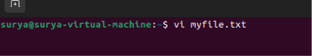

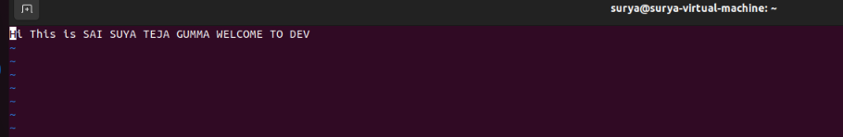

Step 3: View the Contents Using the cat Command

Execute the following command:
cat myfile.txt

Expected output:
Hi This is SAI SUYA TEJA GUMMA WELCOME TO DEVOPS

Explanation:
- cat displays the contents of a file in the terminal.
- myfile.txt is the name of the file being viewed.

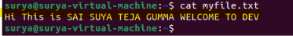

Validation Steps:

Run the following commands to verify that the file exists and contains the expected text:
cd ~
ls -l myfile.txt
cat myfile.txt

Expected file content:

Hi This is SAI SUYA TEJA GUMMA WELCOME TO DEVOPS

Confirm that the filename is correct and that the contents are displayed successfully.

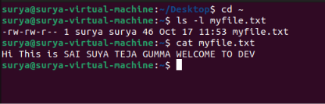

Explanation:

In Ubuntu Linux, the cat command is commonly used to display the contents of a text file directly in the terminal. It is useful for quickly reading short files without opening a separate text editor.
Other commands, such as less and more, can be used to view longer files page by page. The cat -n command displays the contents with line numbers, which can help when examining configuration files or troubleshooting scripts.

Real-Time Use Case:

Linux administrators and developers frequently view configuration files, application logs, shell scripts, and documentation using terminal commands. For example, an administrator may use cat to inspect a configuration file or use less to examine a long system log.

Common Errors and Troubleshooting:

Error or Isuues | Cause | Resolution
No such file or directory | The file does not exist in the current directory. | Run pwd and ls to locate the file.
No output displayed | The file is empty. | Add sample text or inspect another file with content.
Permission denied | The user lacks permission to read the file. | Check permissions using ls -l myfile.txt.
Incorrect content displayed | The file contains different text than expected. | Verify the filename and update the content if necessary.

TASK 8: Copy a file to another location

Outcome:

Successfully copy a file named myfile.txt from the home directory to another location using the cp command in Ubuntu Linux.
Source: /home/surya/myfile.txt
Destination: /home/surya/Documents/myfile.txt

Objective:

To learn how to copy files from one location to another in Ubuntu Linux using the cp command and verify that the copied file exists at the destination.

Prerequisites:

- Ubuntu Linux operating system.
- Logged in to the Ubuntu desktop.
- Access to the Ubuntu terminal.
- A file named myfile.txt created in Task 6.

Step-by-Step Implementation:

Step 1: Navigate to the Home Directory

Verify your current working directory:
pwd

Expected output (example):
/home/surya

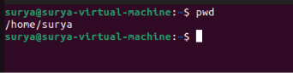

Step 2: Verify the Source File and Destination Directory

Execute the following command to check the source file:
ls -l myfile.txt

Next, verify that the destination directory exists:
ls -ld Documents

Both commands should display information about the specified file or directory.

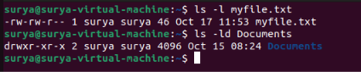

Step 4: Copy the File to Another Location

Execute the following command:
cp myfile.txt Documents/

Explanation:
- cp stands for copy.
- myfile.txt is the source file.
- Documents/ is the destination directory.
- The original file remains in the home directory, and a copy is created inside Documents.

Step 5: Verify the Copied File

Execute the following command:
ls -l Documents/

Expected output should include:
myfile.txt

To verify that the original and copied files contain the same data, execute:
cmp myfile.txt Documents/myfile.txt

If the files are identical, cmp produces no output and returns successfully.

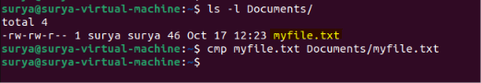

Validation Steps:

Run the following commands:
cd ~
test -f myfile.txt && echo "Source file exists"
test -f Documents/myfile.txt && echo "Copied file exists"
cmp myfile.txt Documents/myfile.txt && echo "Files are identical"

Expected output:

Source file exists
Copied file exists
Files are identical

These results confirm that the original file and the copied file exist and have identical contents.

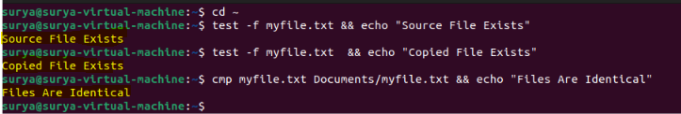

Explanation:

In Ubuntu Linux, the cp command is used to copy files and directories. When copying a file to another directory, the command requires the source path and destination path. For example, cp myfile.txt Documents/ copies the file into Documets while preserving the original file.

Copying files is useful for creating backups, sharing data between directories, and organizing project files. Commands such as ls and cmp help verify the copied file's presence and content.

Real-Time Use Case:
Linux administrators and developers frequently copy configuration files, scripts, documents, and application data to other locations. For example, a developer might copy a script into a project directory before modifying or testing it, while an administrator might copy a configuration file to create a backup.

Common Errors and Troubleshooting:

Error or Issues | Cause | Resolution
No such file or directory | The source file or destination directory does not exist. | Verify both paths using ls.
Permission denied | The user lacks permission to read the source or write to the destination. | Check file and directory permissions.
Not a directory | The destination path refers to a file instead of a directory. | Check the destination using ls -ld Documents.
File already exists at destination | A file with the same name is already present. | Check the existing file before overwriting it.
cmp displays differences | The source and copied files have different contents. | Repeat the copy and compare the files again.

Task 9: Move a file to another location

Outcome:

Successfully move a file named myfile.txt from the home directory to the Downloads folder using the mv command in Ubuntu Linux.

Source: /home/surya/myfile.txt
Destination: /home/username/Downloads/myfile.txt

After moving the file, it will no longer exist in the original location, but it will be available in the destination directory.

Objective:

To learn how to move files from one location to another in Ubuntu Linux using the mv command and verify that the file has been moved successfully.

Prerequisites:

- Ubuntu Linux operating system.
- Logged in to the Ubuntu desktop.
- Access to the Ubuntu terminal.
- A file named myfile.txt.
- A destination directory named Downloads.

Step-by-Step Implementation:

Step 1: Verify the Source File and Destination Directory

Check whether the source file exists:
ls -l myfile.txt

Check whether the destination directory exists:
ls -ld Downloads

Both commands should display information about the file and directory.

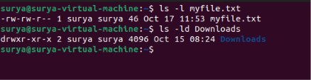

Step 2: Move the File to Another Location

Execute the following command:
mv myfile.txt MyDirectory/

Explanation:
- mv stands for move.
- myfile.txt is the source file.
- Downloads/ is the destination directory.

The file is moved from the home directory into Downloads.
mv moves the file rather than keeping a separate copy at the source location.

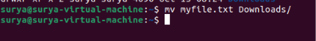

Step 3: Verify the Moved File

Check the contents of the destination directory:
ls -l Downloads/

Expected output should include:
myfile.txt

Now check whether the file still exists in the original location:
ls -l myfile.txt

Expected output:
ls: cannot access 'myfile.txt': No such file or directory

This confirms that the file is no longer in the home directory and is now located in Downloads.

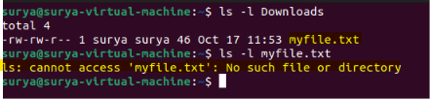

Validation Steps:

Execute the following commands to verify that the move was successful:

test -f ~/Downloads/myfile.txt && echo "File exists at destination"
test ! -e ~/myfile.txt && echo "File removed from source"

Expected output:
File exists at destination
File removed from source

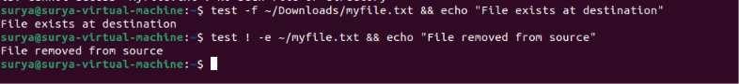

Explanation:

The mv command is used to move files and directories from one location to another. When a file is moved into another directory on the same filesystem, its location changes without creating a second copy. The original filename is preserved unless a different destination filename is specified.
The mv command can also rename files. For example, mv old.txt new.txt renames old.txt to new.txt in the current directory. Care should be taken when the destination already contains a file with the same name, as it may be overwritten.

Real-Time Use Case:

Linux administrators and developers use the mv command to organize files, relocate scripts, move downloaded resources into project directories, and rename configuration files. For example, a developer might move a completed script from the home directory into a project folder to keep related files organized.

Common Errors and Troubleshooting:

Error or Issues | Cause | Resolution
No such file or directory | The source file or destination directory does not exist. | Verify the paths using ls.
Permission denied | The user lacks permission to move the file. | Check the file and destination directory permissions.
Not a directory | The destination path refers to a file instead of a directory. | Verify the destination using ls -ld Downloads.
Destination file already exists | A file with the same name is already present. | Check the existing file before moving; avoid accidental overwriting.
File not found in the original location | The file has already been moved or the current directory is incorrect. | Run pwd and inspect the destination directory.

Task 10: Rename a file

Outcome:

Successfully rename a file named myfile.txt to renamedfile.txt in Ubuntu Linux using the mv command.

Original filename: /home/surya/Downloads/myfile.txt
New filename: renamedfile.txt
Location: /home/surya/Downloads/

Objective:

To learn how to rename a file in Ubuntu Linux using the mv command and verify that the filename has been changed successfully.

Prerequisites:

- Ubuntu Linux operating system.
- Logged in to the Ubuntu desktop.
- Access to the Ubuntu terminal.
- A file named myfile.txt inside the Downloads folder.

Step-by-Step Implementation:

Step 1: Navigate to the Directory

Navigate to the directory containing the file:
cd ~/MyDirectory

Verify your current location:
pwd

Expected output (example):
/home/ubuntu/Downloads

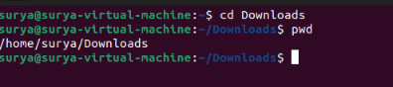

Step 2: Verify the Original File

Execute the following command:
ls -l myfile.txt

This command checks whether the original file exists.

Expected output will display information about myfile.txt.

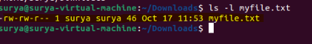

Step 3: Rename the File

Execute the following command:
mv myfile.txt renamedfile.txt

Explanation:
- mv is the Linux command used to move or rename files.
- myfile.txt is the original filename.
- renamedfile.txt is the new filename.

Since both filenames refer to the same directory, the command renames the file without moving it to another location.

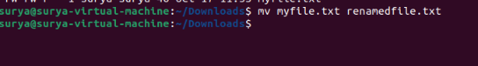

Step 5: Verify the New Filename

To check the new filename directly, execute:
ls -l renamedfile.txt

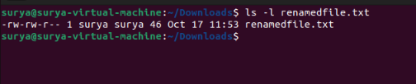

Validation Steps:

Run the following commands to confirm that the file was renamed successfully:

test -f ~/Downloads/renamedfile.txt && echo "File renamed successfully"
test ! -e ~/Downloads/myfile.txt && echo "Original filename no longer exists"

Expected output:
File renamed successfully
Original filename no longer exists

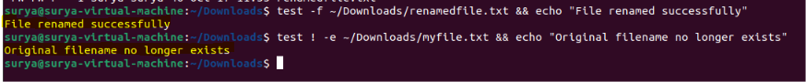

Explanation:

The mv command is used to move files and directories or rename them. When the source and destination filenames are in the same directory, the command changes the filename without creating a separate copy.
For example, mv myfile.txt renamedfile.txt renames myfile.txt to renamedfile.txt. The ls command can then be used to confirm the new filename. Care should be taken if a file with the destination name already exists, as it could be overwritten.

Real-Time Use Case:

Linux administrators and developers rename files to organize projects, update script names, manage configuration files, and identify different versions of documents. For example, a developer might rename script1.sh to backup_script.sh to make its purpose clearer.

Common Errors and Troubleshooting:

Error or issues | Cause | Resolution
No such file or directory | The original file does not exist in the current directory. | Run pwd and ls to verify the location and filename.
Permission denied | The user lacks permission to rename the file. | Check file and directory permissions.
Destination filename already exists | A file with the new name already exists. | Check the existing file before renaming to avoid overwriting it.
New filename not visible | The command may have failed or the file is in another directory. | Run ls -l and verify the command's output.

Task 11: Delete a file

Outcome:

Successfully delete a file named renamedfile.txt from the Downloads folder using the rm command in Ubuntu Linux.

File: renamedfile.txt
Location: /home/surya/Downloads/
Status: Deleted successfully

Objective:

To learn how to delete a file in Ubuntu Linux using the rm command and verify that the file has been removed from the directory.

Prerequisites:

- Ubuntu Linux operating system.
- Logged in to the Ubuntu desktop.
- Access to the Ubuntu terminal.
- A file named renamedfile.txt inside the Downloads folder, created in Task 10.

Step-by-Step Implementation:

Step 1: Navigate to the Directory

Execute the following command:
cd ~/Downloads

Verify the current working directory:
pwd

Expected output (example):
/home/surya/Downloads

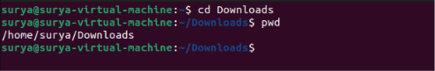

Step 2: Verify the File Before Deleting

Execute the following command:
ls -l renamedfile.txt

This command checks whether the file exists before deletion.

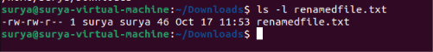

Step 4: Delete the File

Execute the following command:
rm renamedfile.txt

Explanation:
- rm stands for remove.
- renamedfile.txt is the name of the file to delete.
- The command removes the file from the current directory.

Important: The rm command normally deletes a file without moving it to the Trash. Verify the filename before executing the command.



Step 5: Verify the File Deletion

Execute the following command:
ls renamedfile.txt

The file renamedfile.txt should no longer appear in the directory listing.

Expected output:
ls: cannot access 'renamedfile.txt': No such file or directory

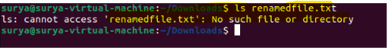

Validation Steps:

Run the following command to verify that the file no longer exists:

test ! -e ~/Downloads/renamedfile.txt && echo "File deleted successfully"

Expected output:
File deleted successfully

Explanation:

The rm command is used to remove files from the filesystem. When a file is deleted using rm, it is normally not sent to the Trash, so recovery may be difficult. Therefore, users should carefully check the filename and location before executing the command.
The ls command lists directory contents, while the test ! -e expression checks that the specified path no longer exists. These commands help verify successful deletion.

Real-Time Use Case:

Linux administrators and developers use the rm command to remove temporary files, outdated scripts, unnecessary logs, and files that are no longer required. For example, a developer may delete an obsolete test file after completing application testing.

Common Errors and Troubleshooting:

Error or Issues | Cause | Resolution
No such file or directory | The file does not exist in the current location. | Run pwd and ls to verify the filename and path.
Permission denied | The user lacks permission to delete the file or modify its parent directory. | Check file and directory permissions.
File still appears in ls | The deletion command may not have executed successfully, or the wrong directory was checked. | Run pwd and check the file location.
Incorrect file deleted | The wrong filename was supplied to rm. | Verify the target before deletion; recovery may require backups or specialized recovery tools.

Task 12: Grant or Revoke Permissions on a File or Directory

Outcome:

Successfully grant and revoke file permissions in Ubuntu Linux using the chmod command and verify the permission changes using the ls -l command.

File: myfile.txt
Permission changes: Read, write, and execute permissions
Status: Permissions modified successfully

Objective:

To learn how to manage file and directory permissions in Ubuntu Linux using the chmod command. This task helps users control who can read, modify, or execute files and access directories.

Prerequisites:

- Ubuntu Linux operating system.
- Logged in to the Ubuntu desktop.
- Access to the Ubuntu terminal.
- Basic knowledge of Linux commands.
- A file named myfile.txt or a directory named MyDirectory in the home directory.

Step-by-Step Implementation:

Step 1: Create a File for Testing

Create a new file named permissionfile.txt:
touch permissionfile.txt

Verify that the file exists:
ls -l permissionfile.txt

Example output:
-rw-rw-r-- 1 ubuntu ubuntu 0 Oct 17 23:00 permissionfile.txt

The permissions and ownership displayed may differ on your system.

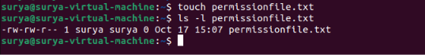

Step 4: Grant Permissions to the File

Execute the following command to grant read, write, and execute permissions to the owner, group, and others:
chmod 777 permissionfile.txt

Explanation:

- chmod stands for change mode.
- 7 represents read, write, and execute permissions.
- The first digit applies to the owner.
- The second digit applies to the group.
- The third digit applies to others.

Permission values:
Number Permission
4 Read (r)
2 Write (w)
1 Execute (x)
7 Read, write, and execute (rwx)

Security note: 777 grants everyone read, write, and execute permissions. This is useful for demonstrating permissions in a lab, but it is generally unsafe for real files. A less permissive example is chmod 644 permissionfile.txt, which gives the owner read/write access and others read-only access.

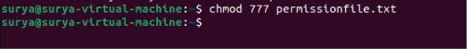

Step 5: Verify the Granted Permissions

Execute the following command:
ls -l permissionfile.txt

Expected output begins with:
-rwxrwxrwx

This indicates that the owner, group, and others have read, write, and execute permissions.

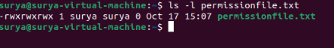

Step 6: Revoke Permissions from the File

Execute the following command to remove write and execute permissions from the group and others while retaining the owner's read, write, and execute permissions:

chmod 755 permissionfile.txt

Explanation:
- The owner retains read, write, and execute permissions.
- The group retains read and execute permissions.
- Others retain read and execute permissions.

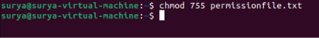

Step 7: Verify the Updated Permissions

Execute:
ls -l permissionfile.txt

Expected output begins with:
-rwxr-xr-x

This confirms that the permissions have been changed.



Validation Steps:

Run the following commands to verify both granting and revoking permissions:

touch permissionfile.txt
chmod 777 permissionfile.txt
ls -l permissionfile.txt
chmod 755 permissionfile.txt
ls -l permissionfile.txt

Expected permission strings:
Operation Expected Permission String
Grant full permissions to everyone -rwxrwxrwx
Restrict write access to the owner -rwxr-xr-x

touch permissionfile.txt

chmod 777 permissionfile.txt

ls -l permissionfile.txt

chmod 755 permissionfile.txt

ls -l permissionfile.txt

Explanation:

Linux permissions control access to files and directories for three categories: the owner, the group, and others. The permissions are read (r), write (w), and execute (x). The chmod command changes these permissions using numeric values or symbolic notation.
For example, chmod 755 permissionfile.txt grants full permissions to the owner and read/execute permissions to the group and others. Symbolic commands such as chmod o-w permissionfile.txt can remove write permission from others, while chmod u+w permissionfile.txt grants write permission to the owner.
For directories, read permission allows listing entries, write permission allows modifying directory entries, and execute permission allows traversing the directory.

Real-Time Use Case:

Linux administrators use file permissions to protect configuration files, scripts, application data, and shared directories. For example, an administrator may allow a script's owner to modify and execute it while permitting other users only to read or execute it. Appropriate permissions help prevent unauthorized changes and protect sensitive data.

Common Errors and Troubleshooting:

Error or Issues | Cause | Resolution
Operation not permitted | The user lacks the required authority to change permissions. | Check file ownership and use an authorized account.
Permission denied | The user does not have permission to access or modify the target. | Check permissions using ls -l.
Permission changes do not appear | The wrong file or directory may have been selected. | Verify the current location using pwd and inspect the filename.
File cannot be executed | Execute permission is missing, or the file is not a valid executable/script. | Check permissions and the file's contents.
Directory cannot be accessed | Execute permission may be missing on the directory. | Check directory permissions and restore appropriate access.

Task 13: View the Current Date and Time

Outcome:

To view the current system date, time, and related time information using commands in the Ubuntu Linux terminal.

Objective:

To learn how to display the current date and time and understand the use of the date command in Ubuntu Linux.

Prerequisites:

- Ubuntu Linux operating system.
- Access to the Terminal.
- Basic knowledge of executing Linux commands.

Step-by-Step Implementation:

Step 2: Display the Current Date and Time

Enter the following command:
date
Press Enter.

Example output:
Sat Oct 17 10:30:00 AM IST 2026

Note: The displayed date and time will depend on your system clock and configured time zone.

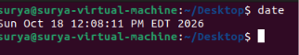

Step 2: Display Only the Current Date
Enter:
date +%F

Example output:
2026-10-17

This displays the date in YYYY-MM-DD format.

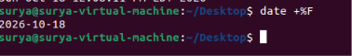

Step 3: Display Only the Current Time

Enter:
date +%T

Example output:
10:30:00

This displays the time in 24-hour format as hours, minutes, and seconds.

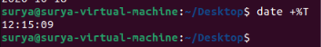

Step 4: Display the Current Date and Time in a Custom Format

Enter:
date "+Date: %d-%m-%Y | Time: %H:%M:%S"

Example output:
Date: 17-10-2026 | Time: 10:30:00

This command displays the date and time in a customized format.

Validation Steps:

Run the following commands one at a time:
date
date +%F
date +%T
timedatectl

Verify that:
- date displays the current system date and time.
- date +%F displays the date in year-month-day format.
- date +%T displays the time in 24-hour format.
- timedatectl displays system time, time zone, and clock synchronization information when available.

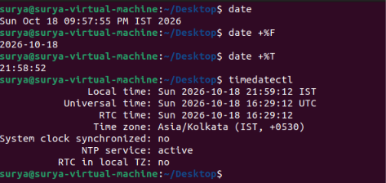

Explanation:

date — Displays the current system date and time.
date +%F — Displays the date in YYYY-MM-DD format.
date +%T — Displays the time in HH:MM:SS format.
timedatectl — Shows system clock and time-zone settings.

Real-Time Use Case:

Viewing the date and time is useful for checking system timestamps, reviewing log files, troubleshooting scheduled tasks, and confirming whether a server's clock and time zone are configured correctly.

Common Errors and Troubleshooting:

Error or Issues | Cause | Resolution
Incorrect displayed time | Wrong time zone configured | Check settings using timedatectl
Incorrect system date | System clock is not synchronized | Check timedatectl for synchronization status
Command not recognized | Typing error | Re-enter the command exactly as shown
Time zone is unexpected | Incorrect system time-zone setting | Review the Time zone field in timedatectl

Task 14: Check the System Uptime

Outcome:

To check how long the Ubuntu Linux system has been running since its last boot and view related system activity information.

Objective:

To learn how to use the uptime command to display system uptime, the current time, the number of logged-in users, and system load averages.

Prerequisites:

- Ubuntu Linux operating system.
- Access to the Terminal.
- Basic knowledge of executing Linux commands.

Step-by-Step Implementation:

Step 1: Check System Uptime

Enter the following command:
uptime
Press Enter.
Example output:
10:45:20 up 2 hours, 15 min, 2 users, load average: 0.12, 0.08, 0.05

The output displays:
10:45:20 — Current system time.
up 2 hours, 15 min — Time elapsed since the system was last started.
2 users — Number of user sessions currently logged in.
Load average — Average system load over the last 1, 5, and 15 minutes.

Note: Your output will vary depending on your system.

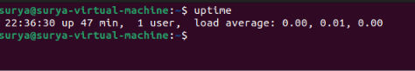

Step 2: Display Uptime in a Readable Format

Enter:
uptime -p

Example output:
up 2 hours, 15 minutes

The -p option displays uptime in a human-readable format.
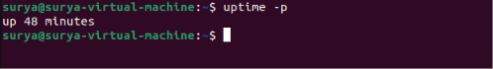

Step 3: Display the Last Boot Time

Enter:
uptime -s

Example output:
2026-10-17 08:30:00

The -s option displays the date and time when the system started.
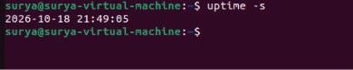

Validation Steps:

Execute the following commands individually:
uptime
uptime -p
uptime -s

Verify that:
- uptime displays the current uptime and load averages.
- uptime -p displays uptime in a readable format.
- uptime -s displays the system's last boot time.

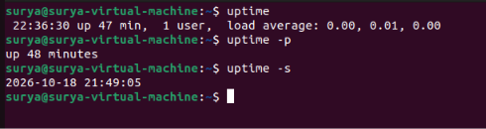

Explanation:

uptime Displays uptime, logged-in users, and load averages
uptime -p Displays uptime in a human-readable format
uptime -s Displays the system's last boot date and time

Real-Time Use Case:

System administrators use uptime to check whether a server has restarted recently, verify service stability, and monitor system load during troubleshooting.
For example, if a server unexpectedly reboots, the uptime -s command helps identify when its current operating session began.

Common Errors and Troubleshooting:

Error or Issues | Cause | Resolution
uptime: command not found | The command utility is unavailable or the environment is restricted | Check the command's availability and system configuration
Uptime is very short | The system recently restarted | Check the boot time using uptime -s
Load averages are high | Heavy system activity | Investigate running processes using top
Logged-in user count differs from expectations | Multiple terminal or remote sessions | Check sessions using who

Task 15: View the Running Processes

Outcome:

To view the processes currently running in Ubuntu Linux and understand how to monitor system activity using terminal commands.

Objective:

To learn how to list running processes, view process IDs (PIDs), and monitor CPU and memory usage.

Prerequisites:

- Ubuntu Linux operating system.
- Access to the Terminal.
- Basic knowledge of executing Linux commands.

Step-by-Step Implementation:

Step 1: Display Running Processes
Enter the following command:
Ps

Press Enter.

Example output:
PID TTY TIME CMD
1520 pts/0 00:00:00 bash
1685 pts/0 00:00:00 ps

This command displays processes associated with the current terminal session.
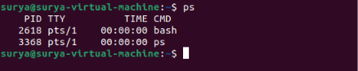

Step 2: Display All Processes

Enter:
ps -ef

Example output:
UID PID PPID C STIME TTY TIME CMD
root 1 0 0 08:30 ? 00:00:02 /sbin/init
user 1520 1400 0 10:40 pts/0 00:00:00 bash
user 1690 1520 0 10:45 pts/0 00:00:00 ps -ef

This command lists processes from all users, including background and system processes. The displayed values are examples; your output will differ.

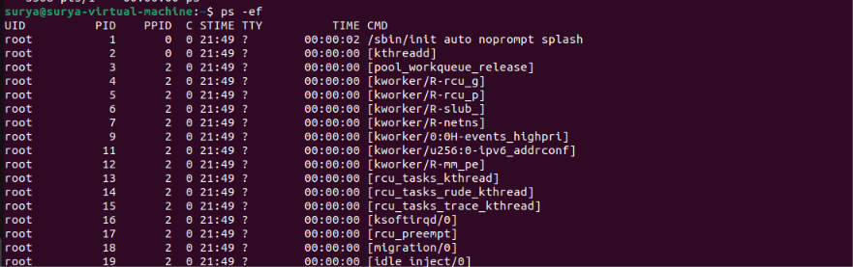

Step 3: Monitor Processes in Real Time

Enter:
top

The terminal displays a live, continuously updated list of processes, along with CPU and memory usage.

Useful controls inside top:
Press q to quit.
Press P to sort by CPU usage.
Press M to sort by memory usage.

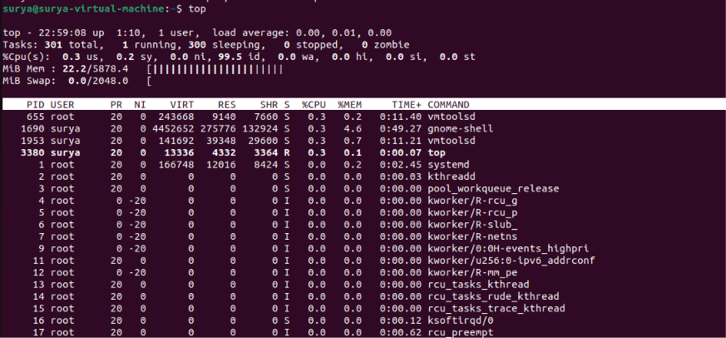

Step 5: Display Processes in a Tree Structure

Enter:
pstree

This displays processes in a parent-child tree structure, helping you understand which processes started other processes.

If the command is unavailable, install the required package:
sudo apt update
sudo apt install psmisc

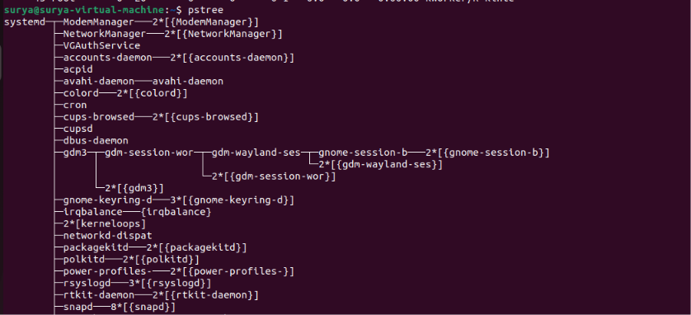
Validation Steps:

Run the following commands individually:
ps
ps -ef
top
pstree

Verify that:
ps displays processes associated with the current terminal.
ps -ef lists processes across the system.
top shows live process and resource information.
pstree displays the process hierarchy.

Explanation:

ps Displays processes associated with the current terminal
ps -ef Lists processes across the system in a detailed format
top Monitors processes and resource usage in real time
pstree Displays processes in a hierarchical tree.

Important process fields:

PID: Unique process identification number.
PPID: Parent process identification number.
%CPU: Percentage of CPU resources used.
%MEM: Percentage of physical memory used.
CMD: Command or program associated with the process.

Real-Time Use Case:

System administrators use process-monitoring commands to identify applications consuming excessive CPU or memory, investigate unresponsive programs, and understand which services are active on a Linux system.

For example, if Ubuntu becomes slow, running top can help identify processes using significant system resources.

Common Errors and Troubleshooting:

Error or Issues | Cause | Resolution
pstree: command not found | Required package is missing | Run sudo apt install psmisc
Process not visible in ps | The process may have ended or is outside the command's scope | Run ps -ef
top screen keeps changing | This is normal real-time behavior | Press q to exit
Permission denied when inspecting certain details | Process information may be restricted | Use appropriate permissions where necessary
Task 16: Kill a Running Process

Outcome:

To learn how to terminate a running process in Ubuntu Linux using the kill command and verify that the process has stopped.

Objective:
To understand how to identify a process ID (PID), send a termination signal to a process, and safely stop a test process from the terminal.

Prerequisites:

- Ubuntu Linux operating system.
- Access to the Terminal.
- Basic knowledge of Linux commands and process IDs.
- A test process that can safely be terminated.

Step-by-Step Implementation:

Step 1: Start a Test Process

Run the following command to start a background process that waits without performing other tasks:
sleep 300 &

Example output:
[1] 2456

The number 2456 is an example PID. Your system will display a different number.
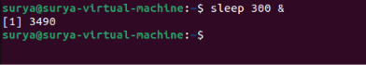

Step 2: Identify the Running Process

Run:
ps -p "$!" -o pid,stat,cmd

This command displays the PID, process status, and command for the process started in Step 2. The special variable $! contains the PID of the most recently started background process in the current shell.

Example output:
PID STAT CMD
2456 S sleep 300

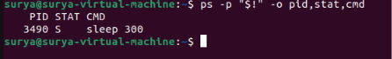

Step 3: Terminate the Process

Run:
kill "$!"

This sends the default SIGTERM signal, which requests that the process terminate gracefully.

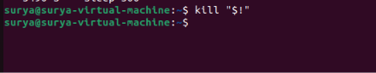

Step 5: Verify That the Process Has Stopped

Run:
ps -p 2456

Replace 2456 with the actual PID from your terminal.
If the process has terminated, the output will typically show only the column headings, with no process entry.
You can also check the most recent background job:
jobs

The shell may report that the job has completed or been terminated.

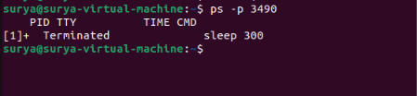
.
Validation Steps:

Run the commands below in sequence, using the same terminal session:
sleep 300 &
ps -p "$!" -o pid,stat,cmd
kill "$!"

Then verify using the actual PID:
ps -p <PID>

Replace <PID> with the numeric process ID. Do not type the angle brackets.
Verify that:
The sleep process starts successfully.
The process appears in the process list.
The kill command sends a termination request.
The process no longer appears after it terminates.

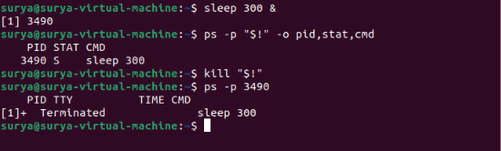

Explanation:

sleep 300 & Starts a test process in the background
ps -p PID Checks a specific process by PID
kill PID Sends the default SIGTERM signal to a process
kill -9 PID Sends SIGKILL to force termination
jobs Lists jobs associated with the current shell

Important: Use kill -9 only when a process does not respond to a normal termination request. It does not allow the process to clean up before stopping.

Real-Time Use Case:

System administrators may need to stop an unresponsive application, terminate a test program, or manage processes that are consuming excessive resources.

For example, if a test application becomes stuck, an administrator can identify its PID with ps and request termination with kill.

Common Errors and Troubleshooting:

Error or Issues | Cause | Solution
No such process | The process has already stopped or the PID is incorrect | Check the PID using ps
Operation not permitted | Insufficient permissions to terminate the process | Check ownership and permissions; use elevated privileges only when authorized
Process still appears after kill | The process has not finished terminating yet | Check again with ps; investigate if it remains active
Incorrect PID used | A different process may be targeted | Verify the PID and command before running kill
kill "$!" targets the wrong process | Another background process was started in the meantime | Save the intended PID immediately and use that explicit PID

Task 17: Install a Package Using the Package Manager

Outcome:

To install a software package in Ubuntu Linux using the APT package manager and verify that the installation was successful.

Objective:

To learn how to update the package list, install a package, and verify the installed software using Linux terminal commands.

Prerequisites:

- Ubuntu Linux operating system.
- Access to the Terminal.
- An active internet connection.
- A user account with sudo privileges.

Step-by-Step Implementation:

Step 1: Update the Package List
Execute the following command:
sudo apt update

Enter your password if prompted. The command refreshes the list of available packages and their versions from the configured software repositories.

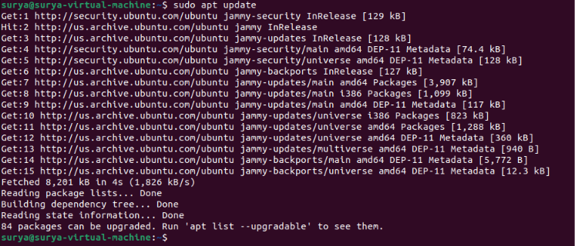

Step 2: Install a Package

For this exercise, install the tree package, which displays files and directories in a tree structure.

Execute:
sudo apt install tree

When prompted to continue, type Y and press Enter.
APT downloads and installs the package and any required dependencies.

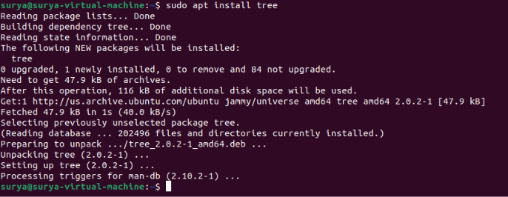

Step 4: Verify the Installation

Execute:
tree --version

Example output:
tree v2.1.1 (c) 1996 - 2023

The version number may differ depending on your Ubuntu release and available package version.

Step 5: Test the Installed Package

Run the following command:
tree ~ -L 2

This displays your home directory's folder structure up to two levels deep.
If the output is lengthy, you can instead test the package in a small directory:
mkdir -p ~/tree_demo/subfolder
touch ~/tree_demo/example.txt
tree ~/tree_demo

Example output:
/home/user/tree_demo
├── example.txt
└── subfolder

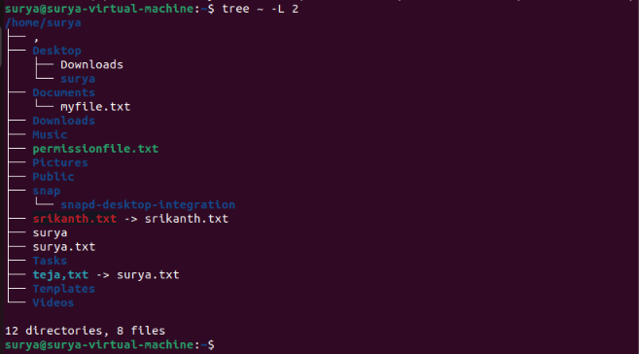

Validation Steps:

Execute these commands individually:

apt list --installed tree
tree --version
tree ~/tree_demo

Verify that:
APT lists the tree package as installed.
The version command displays the installed version.
The tree command displays the directory structure.

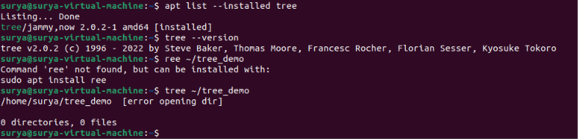

Explanation:

sudo apt update Refreshes available package information
sudo apt install tree Installs the tree package
tree --version Displays the installed version
apt list --installed tree Checks the package's installation status
tree ~/tree_demo Displays a directory structure
Note: Ubuntu uses APT for package management. Other Linux distributions, such as Fedora, use different package managers, including DNF.

Real-Time Use Case:

Package managers are used to install and maintain software such as text editors, system utilities, development tools, and network utilities.

For example, a developer can install a compiler or Git using APT instead of downloading and manually installing software packages.

Common Errors and Troubleshooting:

Error or Issues | Cause | Solution
Unable to locate package | Package lists are outdated or repositories are unavailable | Run sudo apt update and retry
Permission denied | The command lacks administrative privileges | Use sudo where appropriate
Failed to fetch packages | Internet or repository connectivity issue | Check the connection and repository configuration
tree: command not found | Installation failed or the executable is unavailable | Retry installation and inspect any error messages
Insufficient disk space | The system lacks available storage | Check disk usage using df -h

Task 18: Update the System Packages

Outcome:

To update the package lists and upgrade installed software packages in Ubuntu Linux using the APT package manager.

Objective:

To learn how to refresh package information, upgrade installed packages, and verify that the system package update process completes successfully.

Prerequisites:

- Ubuntu Linux operating system.
- Access to the Terminal.
- An active internet connection.
- A user account with sudo privileges.
- Sufficient disk space for package downloads and installation.

Step-by-Step Implementation:

Step 1: Update the Package Lists

Execute the following command:
sudo apt update

Enter your password if prompted.
This command refreshes the local list of available software packages and their versions from the configured repositories. It does not upgrade the installed packages by itself.

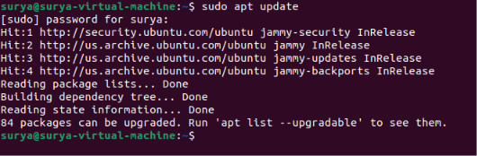

Step 2: Upgrade the Installed Packages

Execute:
sudo apt upgrade

APT displays the packages that can be upgraded and asks for confirmation when necessary. Review the list, then type Y and press Enter to continue.
This downloads and installs available upgrades for installed packages. The command normally avoids removing installed packages to resolve dependencies.

.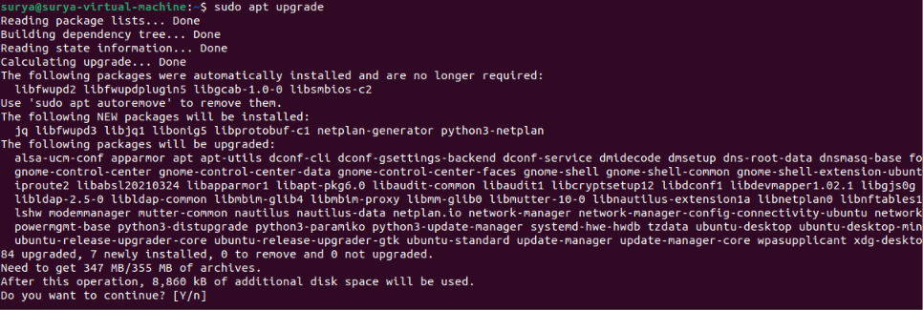
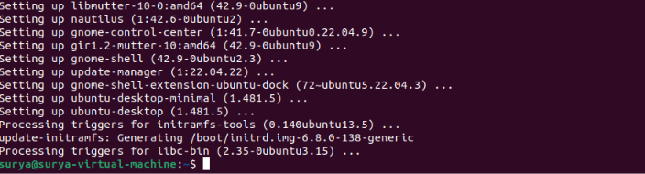

Step 3: Verify the Package Update Status

Execute:
sudo apt update

After it completes, run:
apt list --upgradable

This lists packages for which upgrades are available. If no packages are listed beyond the command's introductory message, there may be no remaining upgrades available from the configured repositories.

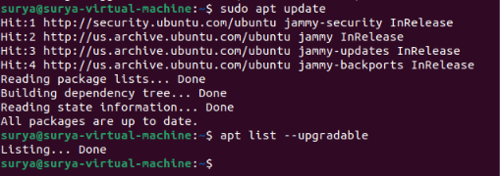

Step 5: Check for a Required Reboot

Execute:
if [ -f /var/run/reboot-required ]; then
echo "A system reboot is required."
else
echo "No system reboot is currently indicated."
fi

Some updates, such as certain kernel or core system updates, may require a reboot to take full effect.

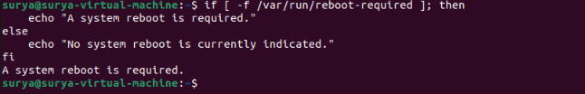

Validation Steps:

Run the following commands individually:
sudo apt update
sudo apt upgrade
apt list --upgradable

Verify that:
The package list update completes without repository errors.
The upgrade process completes successfully.
The remaining upgradeable packages are displayed, if any.
Any reboot requirement is checked before considering the maintenance complete.

Explanation:

sudo apt update Refreshes package information from configured repositories
sudo apt upgrade Upgrades installed packages where possible without normally removing packages
apt list --upgradable Lists packages with available upgrades
df -h Checks available disk space

sudo apt full-upgrade Performs upgrades that may install or remove packages to resolve dependencies

Important: sudo apt full-upgrade may remove packages when necessary. Use it only after reviewing the proposed changes. It is not required for this basic task.

Real-Time Use Case:

System administrators update system packages to receive security fixes, bug fixes, and software improvements. Regular package maintenance helps keep Ubuntu systems reliable and reduces exposure to known software vulnerabilities.

For example, a system administrator may update packages before deploying an application or as part of routine server maintenance.

Common Errors and Troubleshooting:

Error or Issues | Cause | Solution
Unable to fetch some archives | Network or repository connectivity issue | Check the internet connection and retry sudo apt update
Could not get lock | Another package-management process is running | Wait for the other process to finish; do not delete lock files manually
Permission denied | Missing administrative privileges | Use sudo for commands that require it
Insufficient disk space | Not enough storage for downloaded or installed packages | Check available space with df -h
Some packages are kept back | Dependency changes or phased updates | Review APT's explanation and available updates before choosing another upgrade method
Reboot required | A system component needs restarting | Save your work and reboot at an appropriate time

Task 19: Create a Symbolic Link

Outcome:

To create a symbolic link (soft link) to a file or directory in Ubuntu Linux and verify that the link points to the original target.

Objective:

To learn how to use the ln -s command to create symbolic links and understand how they provide convenient access to files and directories from different locations.

Prerequisites:

- Ubuntu Linux operating system.
- Access to the Terminal.
- Basic knowledge of Linux file and directory commands.
- Permission to create files and links in your home directory.

Step-by-Step Implementation:

Step 1: Create a Sample File

Execute the following commands:
mkdir -p ~/symlink_demo
cd ~/symlink_demo
echo "This is the original file." > original.txt

These commands create a test directory and a file named original.txt containing sample text.

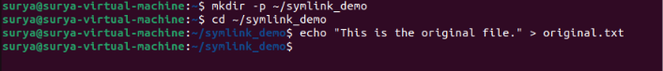

Step 2: Create a Symbolic Link

Run:
ln -s original.txt shortcut.txt

This creates a symbolic link named shortcut.txt that points to original.txt.

Step 4: Verify the Symbolic Link

Execute:
ls -l

Example output:
-rw-rw-r-- 1 user user 27 Oct 18 10:00 original.txt
lrwxrwxrwx 1 user user 12 Oct 18 10:01 shortcut.txt -> original.txt

The arrow (->) indicates that shortcut.txt points to original.txt. The exact permissions, timestamps, and owner names may differ.

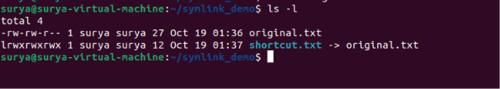

Step 5: Access the Original File Through the Link

Execute:
cat shortcut.txt

Expected output:
This is the original file.

This confirms that you can access the original file's contents through the symbolic link.

Now modify the original file:
echo "Updated content." >> original.txt
cat shortcut.txt

The output will include both lines, demonstrating that the link accesses the updated contents of the target file.

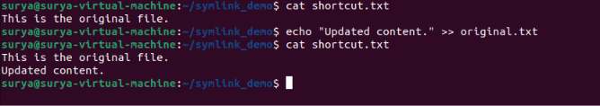

Step 6: Create a Symbolic Link to a Directory

Run:
ln -s ~/symlink_demo ~/symlink_folder
Verify the link:
ls -ld ~/symlink_folder

Example output:
lrwxrwxrwx 1 user user 27 Oct 18 10:05 /home/user/symlink_folder -> /home/user/symlink_demo

You can list the directory contents through the link:
ls ~/symlink_folder

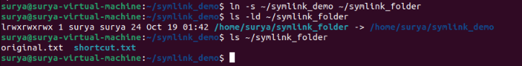

Validation Steps:

Run the following commands individually:
cd ~/symlink_demo
ls -l
readlink shortcut.txt
cat shortcut.txt

Verify that:
ls -l displays shortcut.txt -> original.txt.
readlink shortcut.txt displays the link's target.
cat shortcut.txt displays the target file's contents.
Changes to original.txt are visible through shortcut.txt.

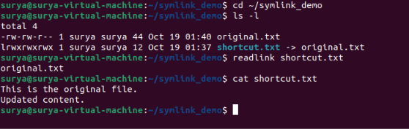

Explanation:

ln -s TARGET LINK Creates a symbolic link
ls -l Displays file details and link targets
readlink LINK Displays the path stored in a symbolic link
cat LINK Reads the target file through the link
ln -s TARGET LINK for a directory Creates a link to a directory

Symbolic link vs. hard link: A symbolic link stores a path to another file or directory. A hard link refers to the same underlying file data and generally cannot be used to link directories in ordinary Linux environments.

A symbolic link can become broken if its target is moved or deleted.

Real-Time Use Case:

Symbolic links are useful when applications expect files in a particular location, when users want shortcuts to frequently accessed directories, or when administrators want a convenient path to a shared resource.

For example, a developer could create a symbolic link to a project directory rather than repeatedly navigating to its full path.

Common Errors and Troubleshooting:

Error or Issues | Cause | Solution
File exists | The link name already exists | Choose another link name or inspect the existing file before changing it
Broken symbolic link | The target was moved or deleted | Restore the target or recreate the link with the correct path
No such file or directory | The target path is incorrect | Verify the target using ls or pwd
Cannot access the target | Insufficient permissions on the target or its parent directories | Check file and directory permissions
Link points to an unexpected location | A relative path was used from a different directory | Verify the target using readlink and use an absolute path when appropriate

Task 20: Search for Files Using the find Command

Outcome:

To search for files and directories in Ubuntu Linux using the find command based on their names, types, and locations.

Objective:

To learn how to locate specific files in a directory hierarchy and use different search options to find files efficiently through the terminal.

Prerequisites:

- Ubuntu Linux operating system.
- Access to the Terminal.
- Basic knowledge of Linux commands and file paths.
- Permission to access the directories being searched.

Step-by-Step Implementation:

Step 1: Create Sample Files for Searching

Execute the following commands:
mkdir -p ~/find_demo
cd ~/find_demo
touch notes.txt report.txt image.jpg
mkdir documents
touch documents/assignment.txt

These commands create sample files and a subdirectory for practicing file searches.

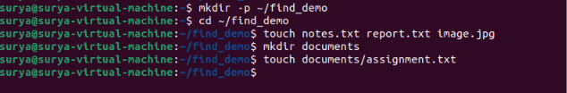

Step 3: Search for a File by Name

Run:
find ~/find_demo -name "report.txt"

Example output:
/home/user/find_demo/report.txt

The -name option searches for an exact filename match, including case.

Step 4: Search for All Text Files

Run:
find ~/find_demo -name "*.txt"

Example output:
/home/user/find_demo/notes.txt
/home/user/find_demo/report.txt
/home/user/find_demo/documents/assignment.txt

The wildcard *.txt matches filenames ending in .txt. The search includes subdirectories by default.

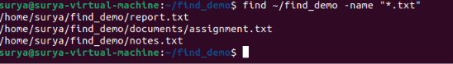

Step 5: Search for Files Without Considering Case

Run:
find ~/find_demo -iname "REPORT.txt"

Example output:
/home/user/find_demo/report.txt

The -iname option performs a case-insensitive filename search.

Step 6: Search Only for Files

Run:
find ~/find_demo -type f

This displays regular files under find_demo, including files inside its subdirectories.

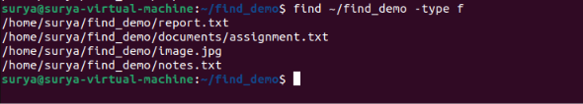

Step 7: Search Only for Directories

Run:
find ~/find_demo -type d

This displays the starting directory and its subdirectories.



Step 8: Search for Files Modified Recently

Run:
find ~/find_demo -type f -mmin -60

This searches for regular files modified within the last 60 minutes.

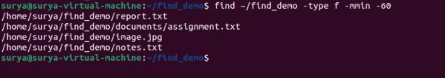

Validation Steps:

Run the following commands individually:
find ~/find_demo -name "report.txt"
find ~/find_demo -name "*.txt"
find ~/find_demo -type f
find ~/find_demo -type d

Verify that:
The exact filename search returns report.txt.
The wildcard search returns the text files.
The -type f option returns regular files.
The -type d option returns directories.

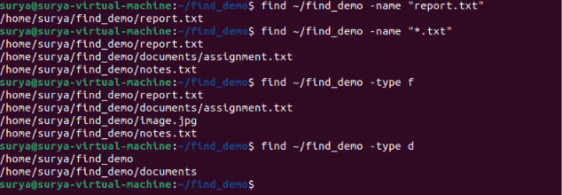

Explanation:

find PATH -name "filename" Searches for a specific filename
find PATH -name "*.txt" Searches for filenames ending in .txt
find PATH -iname "filename" Searches for a filename without case sensitivity
find PATH -type f Finds regular files
find PATH -type d Finds directories
find PATH -type f -mmin -60 Finds files modified within the last 60 minutes

The find command searches recursively by default, meaning it checks the specified directory and its subdirectories.

Real-Time Use Case:

System administrators and users use find to locate configuration files, search project folders, identify recently modified files, and find files with specific extensions.
For example, a developer can search a project directory for all .txt files instead of opening each folder manually.

Common Errors and Troubleshooting:

Error or Issues | Cause | Solution
No results returned | Filename or search path is incorrect | Verify the path and filename
Permission denied | The user lacks permission to access some directories | Search directories you can access, or use authorized elevated privileges when necessary
Too many results | Search path is too broad | Search a specific directory, such as ~/find_demo
File is not found due to capitalization | -name is case-sensitive | Use -iname for a case-insensitive search
find: ‘...’: No such file or directory | The specified path does not exist | Check the path using ls or pwd

Task 21: Compress and Decompress Files Using tar

Outcome:

Create a compressed archive of files and extract the archive when required.

Objective:

Learn to archive and compress files using the Linux tar command.

Prerequisites:

- Ubuntu Linux and Terminal access.
- Permission to create files in your home directory.

Step-by-Step Implementation:

Step 1: Create sample files

mkdir -p ~/tar_demo
cd ~/tar_demo
echo "This is file one." > file1.txt
echo "This is file two." > file2.txt

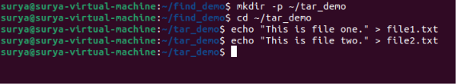

Step 2: Create a tar archive

tar -cvf files.tar file1.txt file2.txt

c: Create an archive.
v: Display processed filenames.
f: Specify the archive filename.

Verify the archive:
ls -lh files.tar

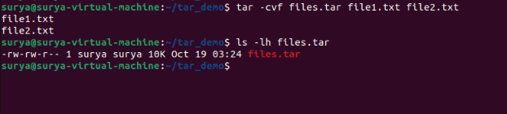

Step 3: Compress the archive using gzip

tar -czvf files.tar.gz file1.txt file2.txt

The -z option enables gzip compression.

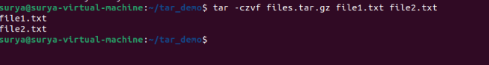

Step 4: Extract the compressed archive

mkdir extracted
tar -xzvf files.tar.gz -C extracted

x: Extract files.
z: Decompress gzip data.
C: Extract into the specified directory.

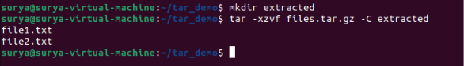

Step 5: Verify the extracted files

ls -l extracted
cat extracted/file1.txt

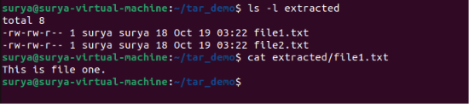

Validation Steps:

tar -tf files.tar.gz
ls -l extracted

Confirm that the archive contains both files and the extracted directory contains their copies.

Explanation:

tar -cvf Creates an uncompressed archive
tar -czvf Creates a gzip-compressed archive
tar -xzvf Extracts a gzip-compressed archive
tar -tf Lists archive contents

Real-Time Use Case:

Administrators use tar archives to back up configuration files, transfer project directories, and bundle application files for deployment.

Common Errors and Troubleshooting:

Error or Issues | Solution
Archive not found | Check the filename and current directory
Permission denied | Use a directory where you have write permission
Extraction fails | Check archive integrity and compression options
Files extract to the wrong location | Specify an appropriate destination with -C

Task 22: Monitor System Resources Using top or htop

Outcome:

Monitor CPU usage, memory usage, and running processes.

Objective:

Learn to inspect system performance using interactive process-monitoring tools.

Prerequisites:

- Ubuntu Linux.
- Terminal access.
- permission to install packages if needed.

Step-by-Step Implementation:

Step 1: Run top

top

Observe CPU usage, memory usage, process IDs, and running processes. Press q to exit.

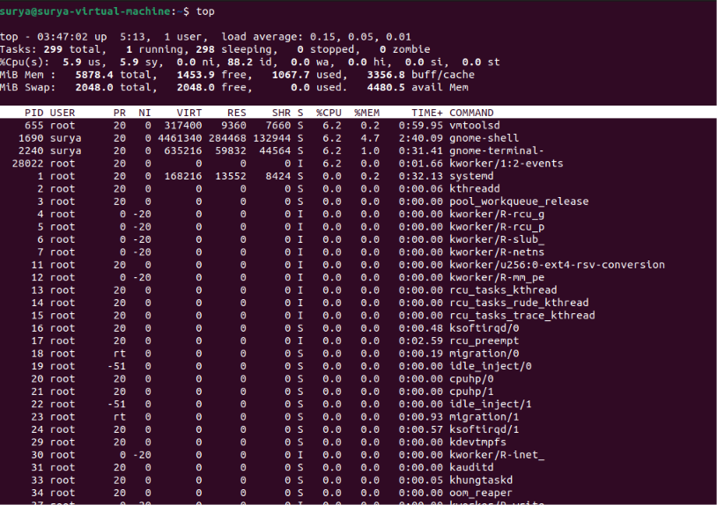

Step 2: Install htop

Execute below commands:
sudo apt update
sudo apt install htop

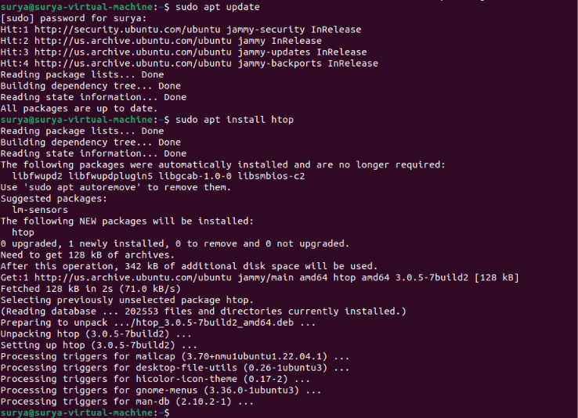

Step 3: Start htop

Execute below command:
htop

Use the interactive display to inspect processes and resource usage. Press q to exit.

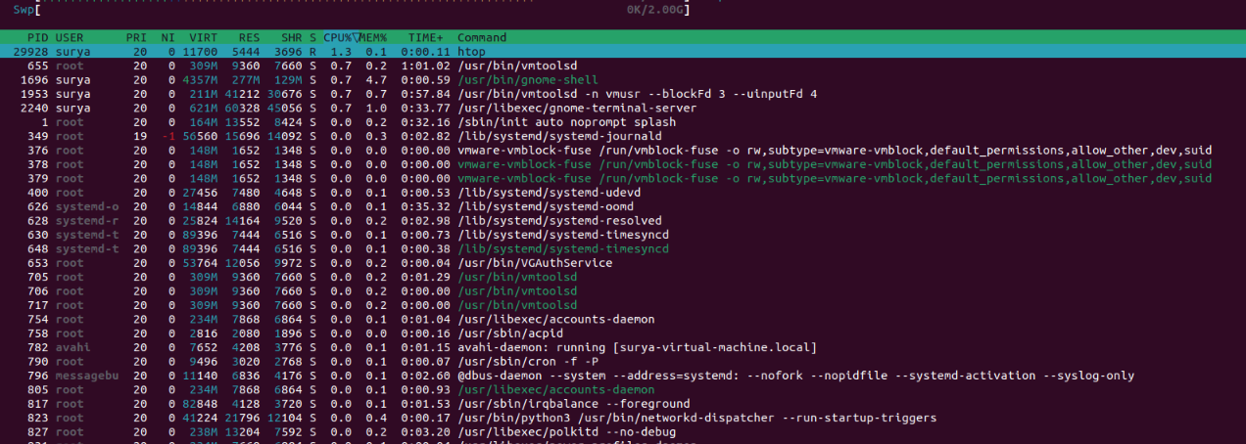

Validation Steps:

top
htop
free -h

Verify that the tools display running processes and that free -h displays memory statistics.

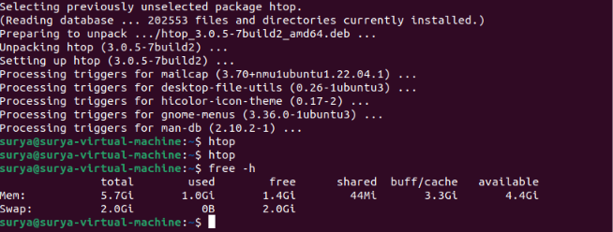

Explanation:

top — Monitors processes and system resources in real time.
htop — Provides an interactive, color-coded process monitor.
free -h — Displays memory usage in human-readable units.

Real-Time Use Case:

Identify applications consuming excessive CPU or memory when a system becomes slow.

Common Errors and Troubleshooting:

Error or Issues | Solution
htop: command not found | Install it using sudo apt install htop
High CPU usage | Inspect processes sorted by CPU usage
Low available memory | Identify memory-heavy processes before taking action

Task 23: Create and Manage User Groups

Outcome:

Create a Linux group, add a user to it, and verify group membership.

Objective:

Learn basic group administration for managing shared access to files and resources.

Prerequisites:

- Ubuntu Linux
- Terminal access
- Account with sudo privileges.

Step-by-Step Implementation:

Step 1: Create a group

sudo groupadd projectteam

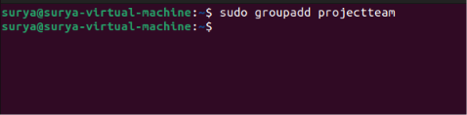

Step 2: Add your current user to the group

sudo usermod -aG projectteam "$USER"

The -aG options append the group without removing existing supplementary group memberships.

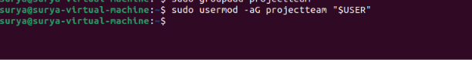

Step 3: Verify the group

getent group projectteam

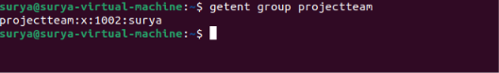

Step 4: Check membership

groups "$USER"

The new group may not appear in your current login session immediately. Log out and log back in, or start a new session, to refresh group membership.

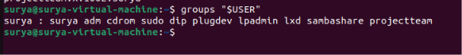

Step 5: Create a shared directory

sudo mkdir -p /srv/projectteam
sudo chown root:projectteam /srv/projectteam
sudo chmod 2770 /srv/projectteam
ls -ld /srv/projectteam

The setgid bit (2 in 2770) helps new items inherit the directory's group.

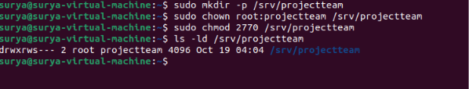

Validation Steps:

getent group projectteam
groups "$USER"
ls -ld /srv/projectteam

Explanation:

groupadd creates a group.
usermod -aG adds a user to supplementary groups.
getent group displays group information.
chown changes ownership.
chmod 2770 gives the owner and group full access, denies access to others, and sets the directory's setgid bit.

Real-Time Use Case:

Create a group for a project team so authorized members can share files without granting access to every system user.

Common Errors and Troubleshooting:

Error or Issues | Solution
Group already exists | Check it with getent group projectteam
Permission denied | Check sudo privileges
New membership not reflected | Start a new login session
Shared directory inaccessible | Check group membership and directory permissions

Task 24: Set Up SSH Passwordless Authentication

Outcome:

Configure SSH public-key authentication so a client can log in to a remote Linux server without entering the account password for each login.

Objective:

Generate an SSH key pair, install the public key on the remote account, and verify the connection.

Prerequisites:

- A client computer with an SSH client.
- A remote Ubuntu server with SSH access.
- A valid remote username and hostname or IP address.
- Permission to access the remote account.

Step-by-Step Implementation:

Step 1: Generate an SSH key pair on the client

ssh-keygen -t ed25519

Press Enter to accept the default file location. Set a passphrase when practical to protect the private key; an SSH agent can remember it during your session.

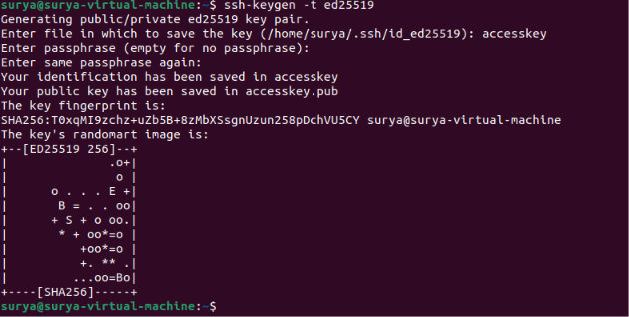

Step 2: Copy the public key to the server

Replace username and server_ip with your actual remote account and server address:

ssh-copy-id username@server_ip

Enter the remote account password when prompted. This installs the public key in the remote account's ~/.ssh/authorized_keys file.

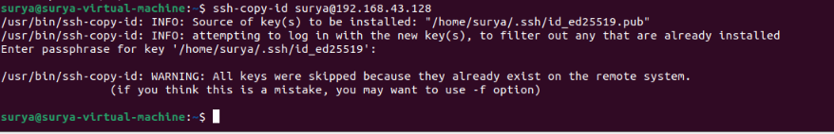

Step 3: Test SSH authentication
ssh username@server_ip

The connection should authenticate using the key. If the private key has a passphrase and is not loaded into an agent, you may still be prompted for that passphrase; that is normal.

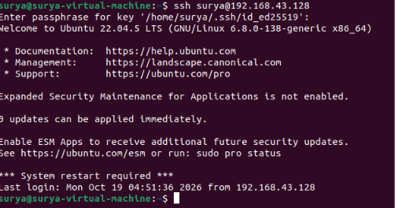

Validation Steps:

ssh -o PreferredAuthentications=publickey username@server_ip

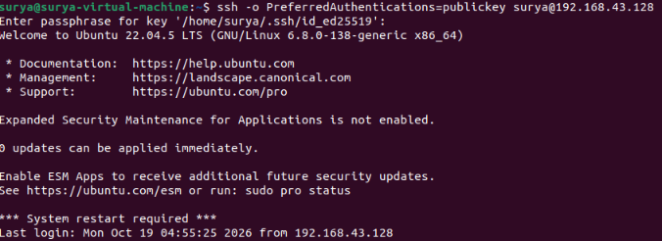

Verify that public-key authentication works. Do not disable password authentication on the server until you have confirmed key-based access in a separate session and ensured you have a recovery method.

Explanation:

ssh-keygen creates a private/public key pair.
ssh-copy-id installs the public key on the remote server.
ssh connects to the remote server.
The private key must remain secret; only the public key is copied.

Real-Time Use Case:

Administrators use SSH keys for secure remote administration, automated deployments, and scripts that connect to servers.

Common Errors and Troubleshooting:

Error or Issue | Solution
Connection refused | Check whether SSH is running and the server is reachable
Permission denied (publickey) | Verify the correct public key and remote username
Host unreachable | Check the IP address, routing, and firewall
Key file permissions rejected | Protect the private key with appropriate permissions; normally chmod 600 ~/.ssh/id_ed25519

Task 25: Monitor Log Files Using tail or grep

Outcome:

Display recent log entries and search logs for a specific pattern.

Objective:

Learn to monitor logs and identify messages related to errors or other events.

Prerequisites:

- Ubuntu Linux.
- Terminal access.
- permission to read the log files.

Step-by-Step Implementation:

Step 1: Display recent log entries

tail -n 20 /var/log/syslog
On systems that do not have /var/log/syslog, use the system journal:

journalctl -n 20

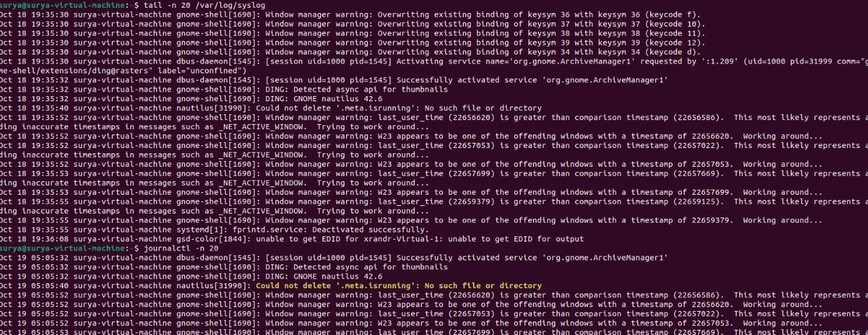

Step 2: Follow a log file in real time

tail -f /var/log/syslog

Press Ctrl + C to stop following the log.

Step 3: Search for errors

grep -i "error" /var/log/syslog

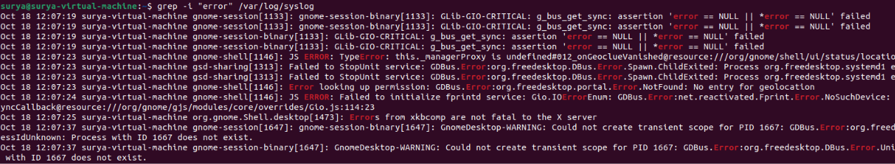

Step 4: Follow the system journal

journalctl -f

Press Ctrl + C to stop.

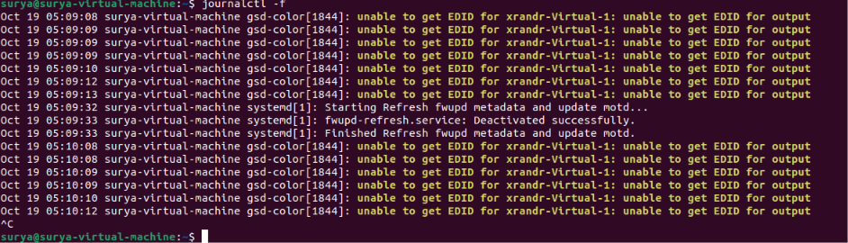

Validation Steps:

tail -n 10 /var/log/syslog
grep -i "error" /var/log/syslog
journalctl -n 10

Use whichever log source exists and is accessible on your system.

Explanation:

tail -n 20 displays the last 20 lines.
tail -f follows a log as new entries are written.
grep -i searches without case sensitivity.
journalctl queries the systemd journal.

Real-Time Use Case:
Monitor service failures, investigate application errors, and inspect system events during troubleshooting.

Common Errors and Troubleshooting:

Error or Issue | Solution
Log file not found | Check available logs or use journalctl
Permission denied | Read only logs you are authorized to access
No matching results | Try a different search term
Too much output | Use tail -n or narrow the grep pattern

Task 26: Set Up a Web Server Using Apache

Outcome:

Install Apache and serve a simple webpage from Ubuntu Linux.

Objective:

Learn to install, start, and test the Apache HTTP web server.

Prerequisites:

- Ubuntu Linux.
- internet connectivity.
- sudo privileges.

Step-by-Step Implementation:

Step 1: Install Apache

sudo apt update
sudo apt install apache2

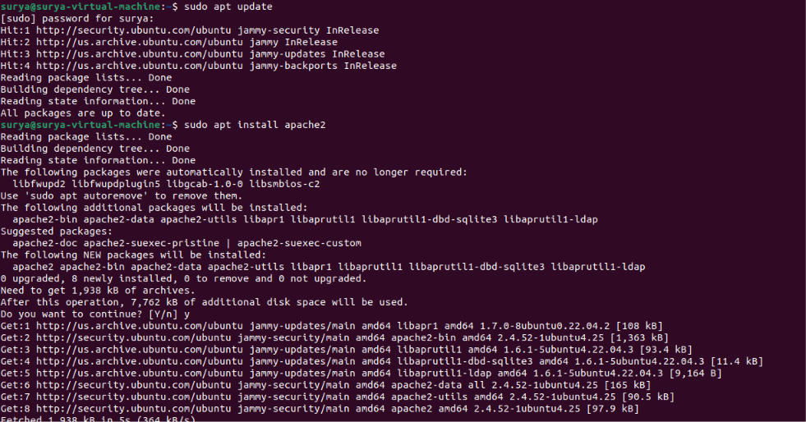

Step 2: Enable and start the service

sudo systemctl enable --now apache2

Step 3: Check the service status

systemctl status apache2

Press q to exit the status view.

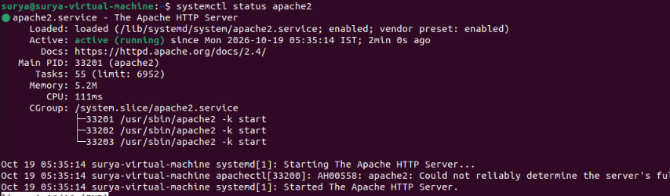

Step 4: Create a simple test webpage

echo '<h1>Welcome to Apache on Ubuntu Linux</h1>' | sudo tee /var/www/html/index.html

Step 5: Test the webpage locally

curl http://localhost

If testing from another computer, use the server's IP address in a browser, and ensure the firewall and network permit HTTP traffic.



Validation Steps:

systemctl is-active apache2
curl -I http://localhost

Confirm the service is active and the HTTP response indicates success.

Explanation:

apt install apache2 installs Apache.
systemctl enable --now enables automatic startup and starts the service.
/var/www/html/ is the default document root on a standard Ubuntu Apache installation.
curl tests an HTTP response.

Real-Time Use Case:

Host websites, internal dashboards, documentation, or test applications.

Common Errors and Troubleshooting:

Error or Issue | Solution
Service fails to start | Inspect sudo journalctl -u apache2
Port 80 is occupied | Identify the service using the port before changing configuration
Browser cannot connect remotely | Check the IP address, routing, and firewall
Page not updated | Verify the document root and the file contents

Task 27: Configure and Secure a MySQL Database

Outcome:

Install MySQL Server, configure its basic security settings, and create a test database.

Objective:

Learn basic database administration and secure database access on Ubuntu Linux.

Prerequisites:

- Ubuntu Linux.
- internet connectivity.
- sudo privileges.

Step-by-Step Implementation:

Step 1: Install MySQL Server

sudo apt update
sudo apt install mysql-server

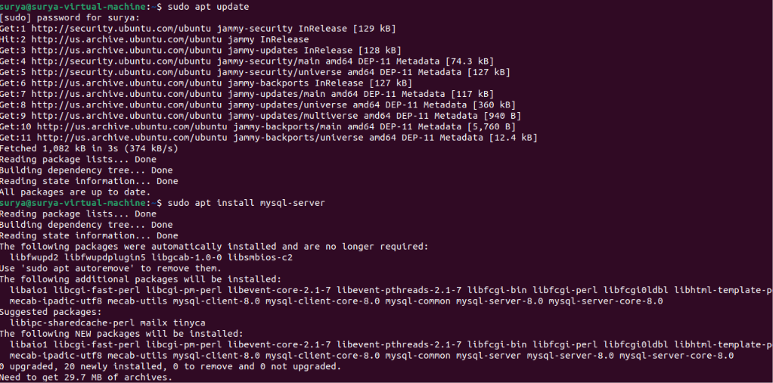

Step 2: Start and enable MySQL

sudo systemctl enable --now mysql
sudo systemctl status mysql

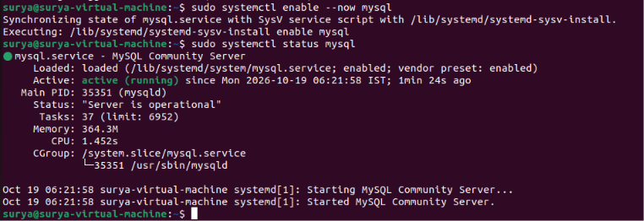

Step 3: Run the security configuration tool
sudo mysql_secure_installation

Follow the prompts to apply appropriate security settings. The available questions depend on the MySQL version and installation. Review each choice before confirming it.

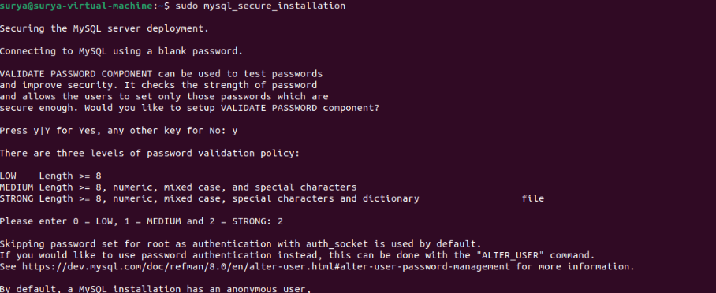

Step 4: Connect to MySQL

On a typical Ubuntu package installation, local administrative access may use socket authentication:

sudo mysql

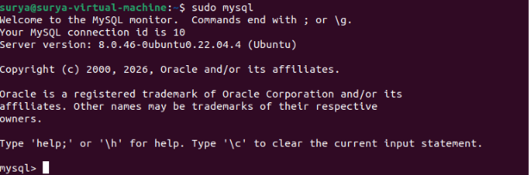

Step 5: Create a test database and a restricted user

At the MySQL prompt, execute the following SQL, replacing the sample password with a strong, unique password:

CREATE DATABASE training_db;

CREATE USER 'training_user'@'localhost'
IDENTIFIED BY 'ReplaceWithAStrongUniquePassword!';

GRANT SELECT, INSERT, UPDATE, DELETE
ON training_db.*
TO 'training_user'@'localhost';

SHOW DATABASES;
EXIT;

Do not reuse the sample password in a real environment. This user is restricted to local connections and basic data operations rather than full administrative privileges.
Screenshot Evidence: Capture the service status, security configuration, and successful database creation. Do not expose real passwords in screenshots.

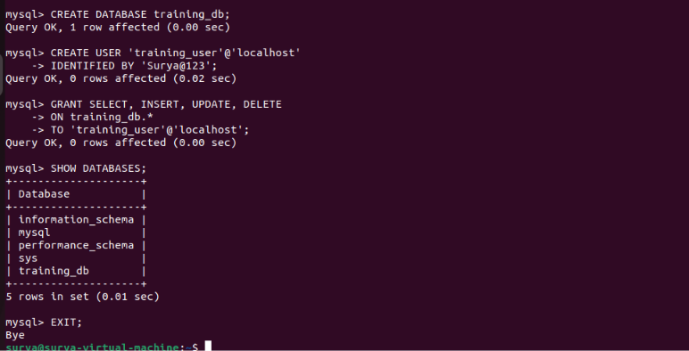

Validation Steps:

sudo systemctl is-active mysql
sudo mysql -e "SHOW DATABASES;"

Test the restricted account by connecting with its credentials using an interactive prompt:
mysql -u training_user -p training_db

Explanation:

mysql-server installs the database server.
mysql_secure_installation helps review security settings.
CREATE DATABASE creates a database.
CREATE USER creates a database account.
GRANT assigns only the required privileges.

Real-Time Use Case:

MySQL stores application data such as user accounts, product information, and transaction records.

Common Errors and Troubleshooting:

Error or Issue | Solution
Service fails to start | Inspect sudo journalctl -u mysql
Access denied | Check the username, authentication method, and grants
Cannot connect | Verify that MySQL is running and that the connection settings are correct
Remote access fails | Check bind settings and network rules; do not expose MySQL publicly without a carefully designed security configuration

Task 28: Set Up an Application Server Using Apache Tomcat

Outcome

Install Apache Tomcat and verify that the application server is running.

Objective:
Learn to install a Java application server and check its service status.

Prerequisites:

- Ubuntu Linux.
- internet connectivity.
- sudo privileges.

Step-by-Step Implementation:

Step 1: Update package information

sudo apt update

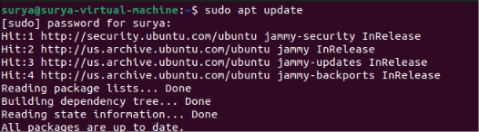

Step 2: Install Java and Tomcat

sudo apt install default-jdk tomcat10

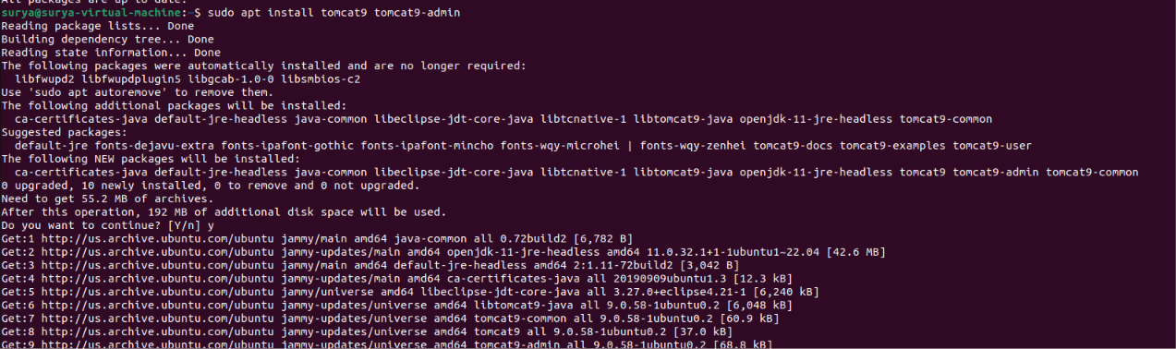

If tomcat10 is unavailable in the configured repositories for your Ubuntu release, check which supported Tomcat packages are available:

apt search tomcat

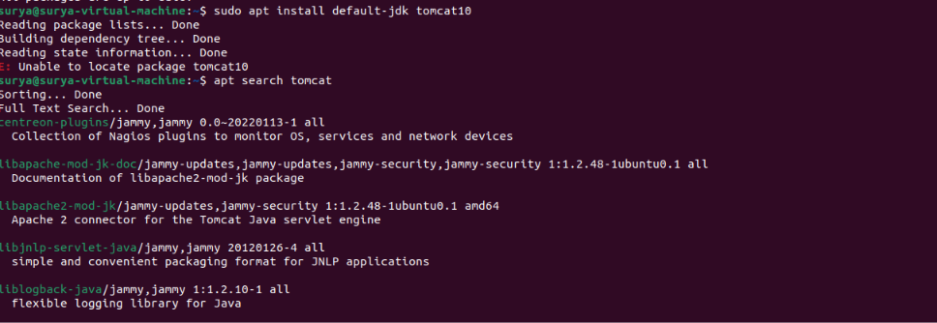

Step 3: Enable and start Tomcat

sudo systemctl enable --now tomcat9

Step 4: Check service status

systemctl status tomcat9

Press q to exit.

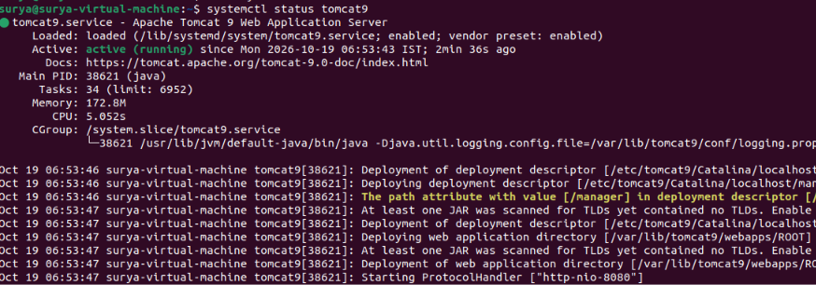

Step 5: Test the server locally

curl -I http://localhost:8080

Tomcat commonly listens on port 8080. A response such as 200 OK or a redirect indicates that an HTTP endpoint responded; the exact result depends on the installed configuration.

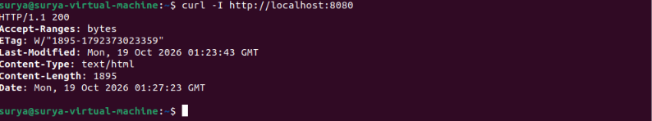

Validation Steps:

java -version
systemctl is-active tomcat9
sudo ss -ltnp | grep ':8080'

Confirm Java is installed, Tomcat is active, and a listener exists on the expected port.

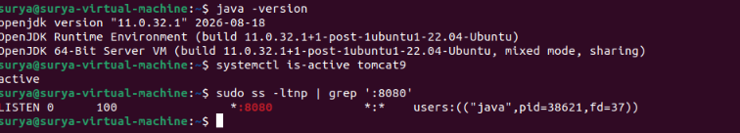

Explanation:

Java provides the runtime required for Tomcat.
Tomcat serves Java web applications.
systemctl manages the service.
curl checks the HTTP endpoint.

Real-Time Use Case:

Tomcat is used to host Java web applications, APIs, and enterprise application components.

Common Errors and Troubleshooting:

Error or Issue | Solution
Package not found | Check the Ubuntu release and available repositories
Tomcat fails to start | Inspect sudo journalctl -u tomcat9
Port 8080 is unavailable | Identify any existing listener before changing port configuration
HTTP connection fails | Check the service status, logs, and connector configuration

Task 29: Create a Service File for Apache Tomcat Using systemctl

Outcome:

Create a custom systemd service unit for a manually installed Tomcat instance and manage it with systemctl.

Objective:

Understand how a systemd unit file defines how Tomcat starts, stops, and restarts.

Prerequisites:

- Ubuntu Linux with systemd.
- Java installed.
- A manual Tomcat installation at /opt/tomcat.
- A dedicated service account named tomcat.

Important: This example assumes Tomcat is manually installed at /opt/tomcat. The APT-managed service from Task 28 is typically named tomcat9 and should not be replaced with this custom unit.

Step-by-Step Implementation:

Step 1: Create a dedicated service account

sudo useradd --system --home-dir /opt/tomcat \
--shell /usr/sbin/nologin tomcat

If the account already exists, do not create it again.

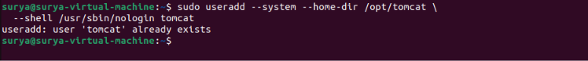

Step 2: Verify the Tomcat installation

ls -l /opt/tomcat/bin/catalina.sh

If this file does not exist, locate your actual Tomcat installation before proceeding.

Step 3: Set ownership

Ensure the service account can read the installation and write to the required runtime directories. For a simple isolated manual installation:

sudo chown -R tomcat:tomcat /opt/tomcat

Only do this if /opt/tomcat is dedicated to this Tomcat instance and you intend that account to own the installation.

Step 4: Create the systemd service file

sudo nano /etc/systemd/system/tomcat-custom.service

Add the following contents:
[Unit]
Description=Apache Tomcat Application Server
After=network.target

[Service]
Type=forking
User=tomcat
Group=tomcat
Environment="JAVA_HOME=/usr/lib/jvm/default-java"
Environment="CATALINA_HOME=/opt/tomcat"
Environment="CATALINA_BASE=/opt/tomcat"
ExecStart=/opt/tomcat/bin/startup.sh
ExecStop=/opt/tomcat/bin/shutdown.sh
Restart=on-failure
RestartSec=5

[Install]
WantedBy=multi-user.target

Save in Nano using Ctrl + O, press Enter, then press Ctrl + X.

Verify that JAVA_HOME points to a valid Java installation and that the startup scripts are executable. This example uses Tomcat's standard startup and shutdown scripts.

Step 5: Reload systemd and start Tomcat

sudo systemctl daemon-reload
sudo systemctl enable --now tomcat-custom

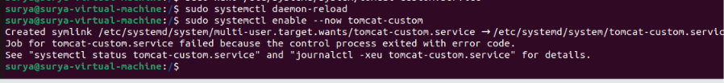

Step 6: Check the service

sudo systemctl status tomcat9 --no-pager

If startup fails, inspect:
sudo journalctl -u tomcat9 -n 50 --no-pager

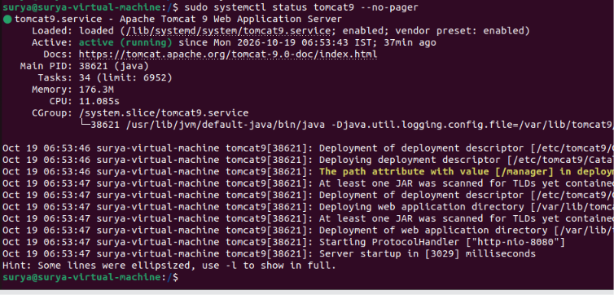

Validation Steps:

sudo systemctl is-enabled tomcat9
sudo systemctl is-active tomcat9
curl -I http://localhost:8080

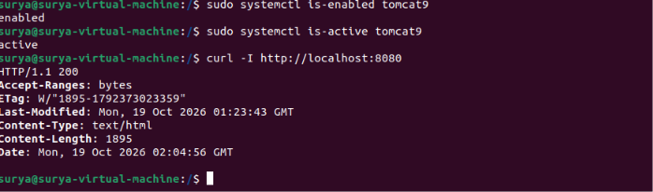

Use systemctl to control the service:

sudo systemctl stop tomcat9
sudo systemctl start tomcat9
sudo systemctl restart tomcat9



Explanation:

/etc/systemd/system/ stores locally created systemd units.
User and Group specify the account running Tomcat.
ExecStart defines the start command.
ExecStop defines the stop command.
daemon-reload makes systemd reread unit files.
enable --now enables startup at boot and starts the service immediately.

Real-Time Use Case:

Create a dedicated service definition when an application server is installed manually rather than through the distribution's package manager.

Common Errors and Troubleshooting:

Error or Issue | Solution
Unit file not found | Check the filename and run daemon-reload
Start script missing | Verify the Tomcat installation path
Java not found | Correct JAVA_HOME
Permission denied | Check ownership, executable permissions, and directory access
Service reports active but HTTP fails | Inspect Tomcat logs and connector settings

Task 30: Print Specific Columns from a Delimited File

Outcome:

Extract and display selected columns from a CSV or other delimited text file.

Objective:

Learn to use awk to select fields based on their column positions.

Prerequisites:

- Ubuntu Linux.
- Terminal access.
- sample delimited file.

Step-by-Step Implementation:

Step 1: Create a CSV file

cat > employees.csv <<'EOF'
ID,Name,Department,Salary
101,Alice,IT,50000
102,Bob,HR,45000
103,Charlie,Finance,55000
EOF

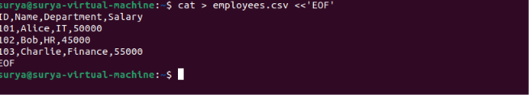

Step 2: Print the name column

awk -F',' '{print $2}' employees.csv

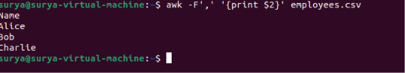

Step 3: Print name and department

awk -F',' 'NR == 1 {print $2, $3}' employees.csv
awk -F',' 'NR > 1 {print $2, $3}' employees.csv

The first command prints the selected header fields; the second prints the selected fields from the data rows.



Step 4: Print ID and salary

awk -F',' 'NR > 1 {print $1, $4}' employees.csv

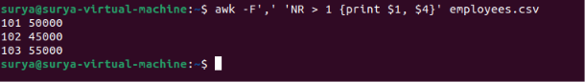

Validation Steps:

cat employees.csv
awk -F',' 'NR > 1 {print $2, $4}' employees.csv

Verify that the names and salary values match the original rows.

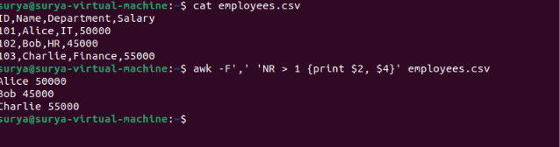

Explanation:

F',' sets the field separator to a comma.
$1, $2, $3, and $4 refer to columns.
NR represents the current record number.

Real-Time Use Case:

Extract selected fields from reports, CSV exports, and tabular text files.

Common Errors and Troubleshooting:

Error or Issue | Solution
Incorrect columns | Check the field order
Entire row appears as one field | Set the correct field separator
Header included unintentionally | Add NR > 1
CSV contains quoted commas | Use a CSV-aware parser for complex CSV files

Task 31: Filter and Print Lines Based on a Pattern or Condition

Outcome:

Display only lines that match a specified text pattern or numerical condition.

Objective:

Use grep and awk to filter file contents.

Prerequisites:

- Ubuntu Linux.
- Terminal access.
- sample file.

Step-by-Step Implementation:

Step 1: Create a sample file

cat > employees.txt <<'EOF'
Alice IT 50000
Bob HR 45000
Charlie IT 60000
Diana Finance 55000
EOF

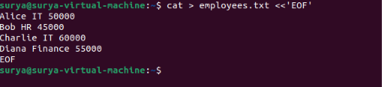

Step 2: Filter lines containing IT

grep 'IT' employees.txt

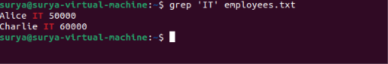

Step 3: Filter case-insensitively

grep -i 'alice' employees.txt



Step 4: Filter records by salary

awk '$3 > 50000' employees.txt

This prints records whose third field is greater than 50,000.


Validation Steps:

grep 'IT' employees.txt
awk '$3 > 50000' employees.txt

Confirm that only matching rows are displayed.

Explanation:

grep searches for text patterns.
grep -i ignores letter case.
awk '$3 > 50000' applies a numeric condition to the third field.

Real-Time Use Case:

Filter server logs, employee records, application output, or data exports to locate specific records.

Common Errors and Troubleshooting:

Error or Issue | Solution
No matches | Check spelling and capitalization
Wrong numeric results | Verify the field position and data format
Unexpected matches | Use a more specific pattern or regular expression

Task 32: Calculate the Average, Sum, or Other Statistics of a Column

Outcome:

Calculate the sum, average, minimum, and maximum of a numeric column.

Objective:

Use awk to perform basic numerical analysis on tabular data.

Prerequisites:

- Ubuntu Linux.
- Terminal access.
- numeric data file.

Step-by-Step Implementation:

Step 1: Create sample data

cat > marks.txt <<'EOF'
Alice 80
Bob 70
Charlie 90
Diana 60
EOF

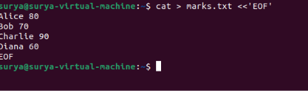

Step 2: Calculate the sum

awk '{sum += $2} END {print "Sum:", sum}' marks.txt

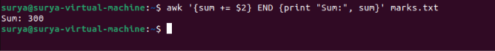

Step 3: Calculate the average

awk '{sum += $2; count++} END {if (count) print "Average:", sum/count}' marks.txt

Step 4: Calculate the minimum and maximum

awk 'NR==1 {min=max=$2} $2<min {min=$2} $2>max {max=$2} END {print "Minimum:",min; print "Maximum:",max}' marks.txt

Validation Steps:

Expected results for the sample data:
Sum: 300
Average: 75
Minimum: 60
Maximum: 90

Re-run the commands and compare the output with these values.

Explanation;

sum += $2 accumulates the values.
count++ counts records.
END runs after all input records are processed.
The average is the sum divided by the number of records.

Real-Time Use Case:

Calculate average marks, total sales, maximum readings, or minimum measurements from text-based reports.

Common Errors and Troubleshooting:

Error or Issue | Solution
Average is incorrect | Verify the numeric column
Text is included in calculations | Exclude headers or nonnumeric records
Empty input | Check that the file contains data
Decimal output needs formatting | Use printf, such as printf "%.2f\n", sum/count

Task 33: Perform String Manipulation Using awk

Outcome:

Extract substrings and change the case of text.

Objective:

Learn basic string operations in awk.

Prerequisites:

- Ubuntu Linux.
- Terminal access.
- sample text file.

Step-by-Step Implementation:

Step 1: Create a sample file

echo "ubuntu linux administration" > words.txt

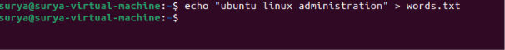

Step 2: Convert text to uppercase

awk '{print toupper($0)}' words.txt

Step 3: Convert text to lowercase

echo "UBUNTU LINUX" | awk '{print tolower($0)}'

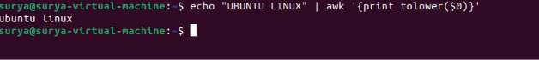

Step 4: Extract a substring

echo "UbuntuLinux" | awk '{print substr($0, 1, 6)}'

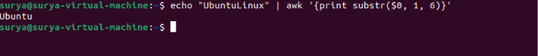

Step 5: Print the length of the string

awk '{print length($0)}' words.txt

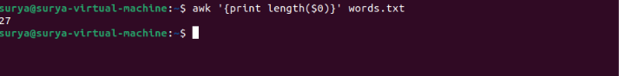

Validation Steps:

awk '{print toupper($0)}' words.txt
awk '{print tolower($0)}' words.txt
echo "UbuntuLinux" | awk '{print substr($0,1,6)}'

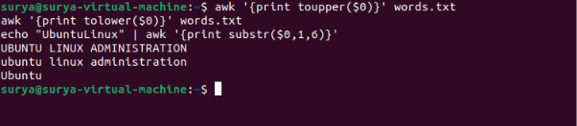

Explanation:

toupper() converts text to uppercase.
tolower() converts text to lowercase.
substr(text, start, length) extracts part of a string; positions start at 1.
length() returns the string length.

Real-Time Use Case:

Normalize text, extract identifiers, and transform fields in reports or data files.

Common Errors and Troubleshooting:

Error | Solution
Wrong substring | Check the starting position and requested length
Unexpected capitalization | Check which function is being used
Field differs from expected text | Use $0 for the entire line or the appropriate field such as $1

Task 34: Count the Occurrences of a Specific Pattern in a File

Outcome:

Count the number of lines containing a specified pattern.

Objective:

Use grep to search for patterns and count matching lines.

Prerequisites:

- Ubuntu Linux.
- Terminal access.
- sample text file.

Step-by-Step Implementation:

Step 1: Create a sample file

cat > log.txt <<'EOF'
INFO Application started
ERROR Connection failed
INFO Request received
ERROR Timeout occurred
ERROR Retry failed
EOF

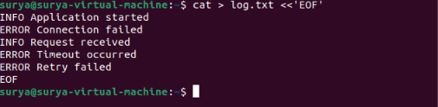

Step 2: Count matching lines

grep -c 'ERROR' log.txt



Step 3: Count matches without considering case

grep -ic 'error' log.txt

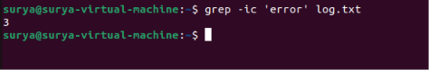

Step 4: Count individual pattern occurrences

To count every occurrence of error, including multiple occurrences on one line:

grep -oi 'error' log.txt | wc -l

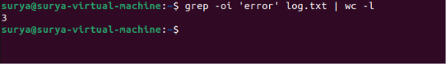

Validation Steps:

grep -n 'ERROR' log.txt
grep -c 'ERROR' log.txt

Verify that the number of matching lines agrees with the displayed matching line numbers.

Explanation:

grep -c counts matching lines.
grep -i ignores case.
grep -o prints each match separately.
wc -l counts output lines.

Real-Time Use Case:

Count error messages in server logs, occurrences of status codes, or matching records in a text file.

Common Errors and Troubleshooting:

Error | Solution
Count is zero | Check the pattern and letter case
Count seems too low | Use grep -o to count individual occurrences
Pattern contains special characters | Quote the pattern and use fixed-string matching with grep -F when appropriate

Task 35: Sort Lines Based on a Specific Field or Column

Outcome:

Sort records alphabetically or numerically by a selected field.

Objective:

Use the sort command to order data in a text file.

Prerequisites:

- Ubuntu Linux.
- Terminal access.
- sample delimited file.

Step-by-Step Implementation:

Step 1: Create a sample file

cat > scores.txt <<'EOF'
Alice 80
Bob 95
Charlie 70
Diana 85
EOF

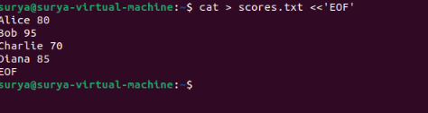

Step 2: Sort alphabetically

sort scores.txt



Step 3: Sort by score numerically

sort -k2,2n scores.txt

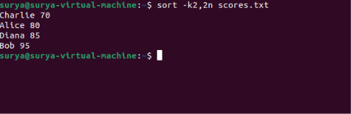

Step 4: Sort scores in descending order

sort -k2,2nr scores.txt

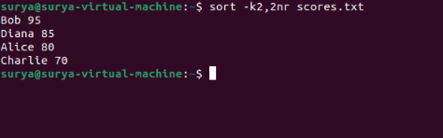

Step 5: Save the sorted output

sort -k2,2n scores.txt > scores_sorted.txt

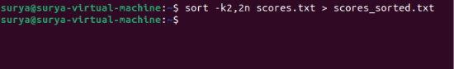

Validation Steps:

cat scores_sorted.txt
sort -c -k2,2n scores_sorted.txt

If the file is correctly sorted, the sort -c command completes without reporting an ordering error.

Explanation:

sort sorts lines.
k2,2 selects the second field.
n sorts numerically.
r reverses the order.
> redirects the output into a file.

Real-Time Use Case:

Sort employee salaries, test scores, inventory quantities, or tabular reports.

Common Errors and Troubleshooting:

Error | Solution
Numbers sort incorrectly | Use numeric sorting with -n
Wrong field selected | Check the column number and field separator
Original file overwritten | Use a separate output filename
Decimal or locale behavior differs | Check the data format and locale settings

Task 36: Merge Multiple Files Based on a Common Field or Column

Outcome:

Combine records from two files using a common key.

Objective:

Learn to use the join command to merge related data from two sorted files.

Prerequisites:

- Ubuntu Linux.
- Terminal access.
- two text files with a common field.

Step-by-Step Implementation:

Step 1: Create the first file

cat > employees.txt <<'EOF'
101 Alice
102 Bob
103 Charlie
EOF

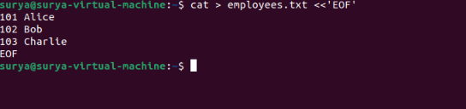

Step 2: Create the second file

cat > departments.txt <<'EOF'
101 IT
102 HR
103 Finance
EOF

Both files are sorted by their first field, which is the common employee ID.

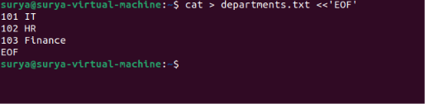

Step 3: Merge the files

join employees.txt departments.txt



Step 4: Save the merged output

join employees.txt departments.txt > merged.txt
cat merged.txt

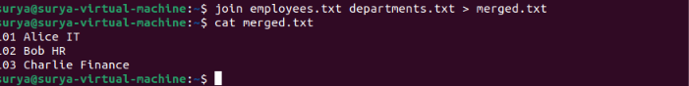

Validation Steps:

join employees.txt departments.txt
cat merged.txt

Verify that each employee is matched with the correct department using the shared ID.

Explanation:

join combines records based on a common field.
By default, it uses the first field and expects the files to be sorted by that field.
Records without a matching key are omitted by default.

Real-Time Use Case:

Combine employee information with department records or merge product IDs with inventory data.

Common Errors and Troubleshooting:

Error | Solution
Records fail to match | Check that the key values are identical
Incorrect output | Verify that both files are sorted by the join field
Different key column | Use join -1 and join -2 to select the relevant fields

Task 37: Substitute Text in a File Using Search and Replace

Outcome:

Replace specific text in a file using the sed command.

Objective:

Learn basic text substitution and how to save changes to a file.

Prerequisites:

- Ubuntu Linux.
- Terminal access.
- sample text file.

Step-by-Step Implementation:

Step 1: Create a sample file

echo "Linux is useful. Linux is powerful." > message.txt

Step 2: Replace the first occurrence on each line

sed 's/Linux/Ubuntu/' message.txt

Step 3: Replace all occurrences on each line

sed 's/Linux/Ubuntu/g' message.txt

Step 4: Save the changes to a new file

sed 's/Linux/Ubuntu/g' message.txt > updated.txt
cat updated.txt

Step 5: Edit the original file in place

After checking the output, you can create a backup and modify the original:

sed -i.bak 's/Linux/Ubuntu/g' message.txt

This creates message.txt.bak as a backup.

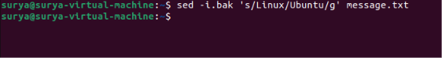

Validation Steps:

cat message.txt
cat message.txt.bak

Verify that the modified file contains the replacement text and the backup retains the original content.

Explanation:

s/old/new/ replaces the first matching occurrence on each line.
g replaces all matching occurrences on each line.
i.bak edits the file in place and creates a backup.

Real-Time Use Case:

Update configuration values, replace outdated names, or transform text in log files and reports.

Common Errors and Troubleshooting:

Error | Solution
Text is not replaced | Check the pattern and letter case
Only one occurrence changes | Add the g flag
Original file is accidentally changed | Create a backup or redirect output to a new file
Special characters cause issues | Escape special characters or choose a suitable delimiter

Task 38: Delete Specific Lines Based on a Pattern or Line Number

Outcome:

Remove selected lines from text output or create a modified file without those lines.

Objective:

Use sed to delete lines by line number or matching pattern.

Prerequisites:

- Ubuntu Linux.
- Terminal access.
- sample file.

Step-by-Step Implementation:

Step 1: Create a sample file

cat > notes.txt <<'EOF'
Line one
Remove this line
Line three
Remove this entry
Line five
EOF

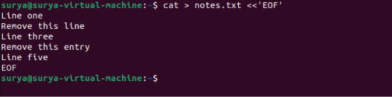

Step 2: Delete line 2 from the output

sed '2d' notes.txt

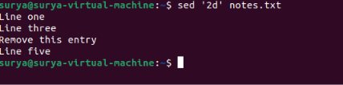

Step 3: Delete lines matching a pattern

sed '/Remove/d' notes.txt

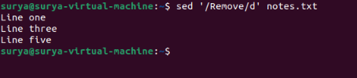

Step 4: Save the filtered result

sed '/Remove/d' notes.txt > cleaned.txt
cat cleaned.txt

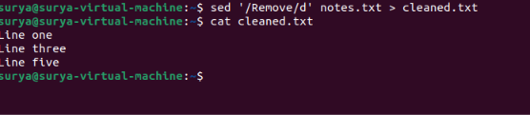

Validation Steps:

cat notes.txt
cat cleaned.txt

Verify that the original file remains unchanged and the output file excludes the matching lines.

Explanation:

2d deletes the second line from the output.
/pattern/d deletes lines matching a pattern.
Redirection saves the transformed output into another file.

Real-Time Use Case:

Remove unwanted records, comments, or matching entries from text reports.

Common Errors and Troubleshooting:

Error | Solution
Wrong line deleted | Check the line number
More lines deleted than expected | Make the search pattern more specific
Original data lost | Write output to a new file or create a backup

Task 39: Append or Insert Text Before or After a Specific Pattern or Line

Outcome:

Insert additional text before or after a matching line using sed.

Objective:

Learn to add lines to a text file based on a line number or search pattern.

Prerequisites:

- Ubuntu Linux.
- Terminal access.
- sample text file.

Step-by-Step Implementation:

Step 1: Create a sample file

cat > plan.txt <<'EOF'
Introduction
Installation
Testing
Conclusion
EOF

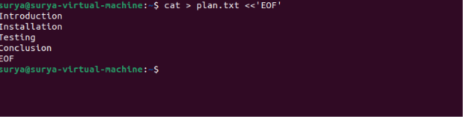

Step 2: Insert a line before a matching pattern

sed '/Testing/i\Configuration' plan.txt

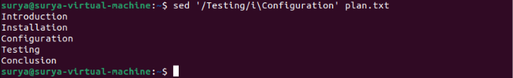

Step 3: Append a line after a matching pattern

sed '/Installation/a\Verification' plan.txt

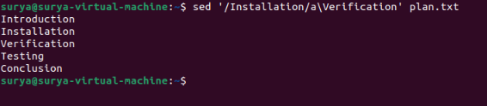

Step 4: Insert text before line 2

sed '2i\Preparation' plan.txt

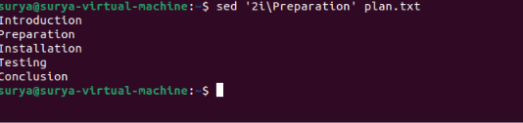

Step 5: Save the modified output

sed '/Installation/a\Verification' plan.txt > updated_plan.txt
cat updated_plan.txt

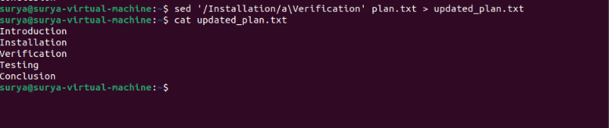

Validation Steps:

cat plan.txt
cat updated_plan.txt

Verify that the inserted text appears in the intended position and that the original file is unchanged.

Explanation:

i\text inserts text before the selected line.
a\text appends text after the selected line.
A numeric address selects a line number.
A pattern address selects matching lines.
Real-Time Use Case:

Add configuration entries, insert headings into reports, or add instructions around matching sections of a text file.

Common Errors and Troubleshooting:

Error | Solution
Text inserted in the wrong place | Check the line number or pattern
Multiple insertions occur | The pattern may match multiple lines
Formatting is incorrect | Check spaces and escaping in the sed expression

Task 40: Print Only Specific Lines from a File

Outcome:

Display selected lines from a text file without printing the entire file.
Objective:

Learn to extract lines using sed, head, and tail.

Prerequisites:

- Ubuntu Linux.
- Terminal access.
- sample file.

Step-by-Step Implementation:

Step 1: Create a sample file

seq 1 10 > numbers.txt

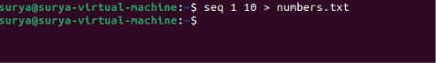

This creates a file containing numbers 1 through 10, one per line.

Step 2: Print a specific line

sed -n '5p' numbers.txt

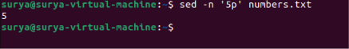

Step 3: Print a range of lines

sed -n '3,6p' numbers.txt

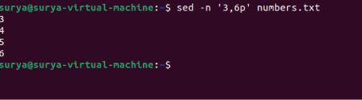

Step 4: Print the first three lines

head -n 3 numbers.txt

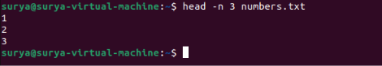

Step 5: Print the last three lines

tail -n 3 numbers.txt

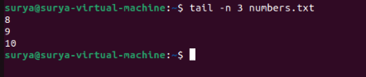

Validation Steps:

sed -n '5p' numbers.txt
sed -n '3,6p' numbers.txt

Confirm that the output contains only the requested line or line range.

Explanation:

sed -n '5p' prints only line 5.
sed -n '3,6p' prints lines 3 through 6.
head -n 3 prints the first three lines.
tail -n 3 prints the last three lines.

Real-Time Use Case:

Inspect a section of a large configuration file or report without displaying its entire contents.

Common Errors and Troubleshooting:

Error | Solution
No output | Verify the requested line number exists
Wrong lines displayed | Check the line range
Entire file printed unexpectedly | Use -n with sed when selecting specific lines

Task 41: Copy a File from Linux to a Windows Machine

Outcome:

Transfer a file from Ubuntu Linux to a Windows computer over a network using SSH and scp.

Objective:

Learn to securely copy files between Linux and Windows systems.

Prerequisites:

- Ubuntu Linux client.
- Windows computer reachable over the network.
- OpenSSH Server installed and running on Windows.
- A Windows account permitted to connect using SSH.
- Network access to the SSH port, normally TCP port 22.

Step-by-Step Implementation:

Step 1: Create a sample file on Linux

echo "File transferred from Ubuntu Linux." > ~/transfer.txt

Step 2: Check Windows SSH connectivity

On Windows, ensure OpenSSH Server is installed and running. In an elevated PowerShell session, an administrator can check:

Get-Service sshd

If necessary, an administrator can start it:

Start-Service sshd

The Windows firewall must permit the SSH connection. Follow your organization's security policy when configuring the firewall.

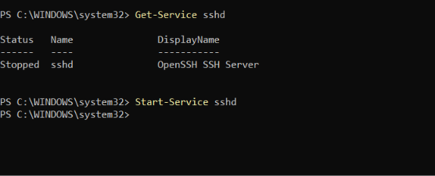

Step 3: Copy the file using scp

On Ubuntu, run the following, replacing the placeholders with the actual Windows username, IP address, and destination directory:
Scp~/transfer.txt WINDOWS_USER@WINDOWS_IP:'C:/Users/WINDOWS_USER/Downloads/'

For example, the destination directory must exist and the Windows account must have permission to write to it. You may be prompted to confirm the server's host key on the first connection and then enter the Windows account's authentication details.

Step 4: Verify the copied file on Windows

In Windows PowerShell:

Get-Content "$env:USERPROFILE\Downloads\transfer.txt"

Validation Steps:

On Ubuntu:
ls -l ~/transfer.txt

On Windows PowerShell:
Test-Path "$env:USERPROFILE\Downloads\transfer.txt"
Get-Content "$env:USERPROFILE\Downloads\transfer.txt"

Confirm that the destination file exists and its contents match the source.
Explanation:

scp securely copies files over SSH.
WINDOWS_USER is the Windows account name.
WINDOWS_IP is the Windows machine's network address.
The destination path specifies where the file should be saved.
Real-Time Use Case:

Transfer reports, scripts, logs, and configuration files between Linux servers and Windows workstations.

Common Errors and Troubleshooting:

Error | Solution
Connection refused | Check whether the Windows sshd service is running
Connection timed out | Check network connectivity and firewall rules
Permission denied | Verify the Windows account and authentication method
Destination path not found | Check the Windows directory path
Host key warning | Verify the server's identity before accepting a new host key

Task 42: Five Use Cases for awk and Five Use Cases for sed

Outcome:

Use awk and sed to perform common text-processing tasks in Ubuntu Linux.

Objective:

Understand the difference between awk, which is well suited to field-based processing and calculations, and sed, which is commonly used for stream editing and line transformations.

Prerequisites:

Ubuntu Linux.
Terminal access.
Basic knowledge of shell commands.

Step-by-Step Implementation:

Step 1: Create a sample data file

cat > employees.csv <<'EOF'
ID,Name,Department,Salary
101,Alice,IT,50000
102,Bob,HR,45000
103,Charlie,IT,60000
104,Diana,Finance,55000
EOF

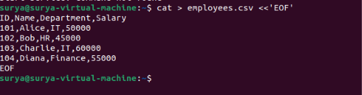

Step 2: Five use cases for awk

Use case 1: Print selected columns

awk -F',' 'NR>1 {print $2, $3}' employees.csv

Prints employee names and departments, excluding the header.

Use case 2: Filter records by a condition

awk -F',' 'NR>1 && $4>50000' employees.csv

Prints records with a salary greater than 50,000.

Use case 3: Calculate the total salary

awk -F',' 'NR>1 {sum+=$4} END {print "Total salary:",sum}' employees.csv

Use case 4: Calculate the average salary

awk -F',' 'NR>1 {sum+=$4; count++} END {if(count) printf "Average salary: %.2f\n",sum/count}' employees.csv

Use case 5: Convert names to uppercase

awk -F',' 'BEGIN{OFS=","} NR==1{print; next} {$2=toupper($2); print}' employees.csv

This prints a transformed CSV representation to the terminal; it does not modify the original file.

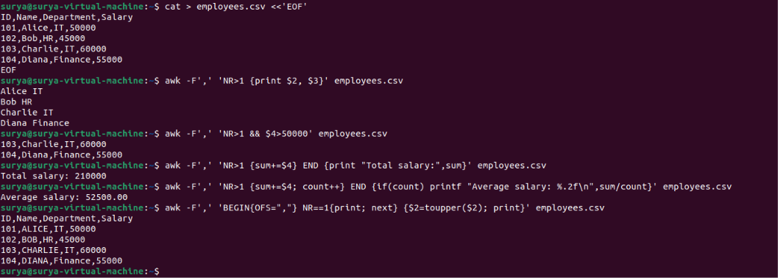

Step 3: Five use cases for sed

Use case 1: Replace text

sed 's/IT/Technology/g' employees.csv

Replaces every IT occurrence on each line.

Use case 2: Delete the header

sed '1d' employees.csv

Displays all lines except the first.

Use case 3: Print only a line range

sed -n '2,3p' employees.csv

Displays lines 2 and 3.

Use case 4: Insert text before a matching line

sed '/102/i\Employee record follows:' employees.csv

Inserts a line before the line containing 102.

Use case 5: Remove lines matching a pattern

sed '/Finance/d' employees.csv

Displays all lines except those containing Finance.

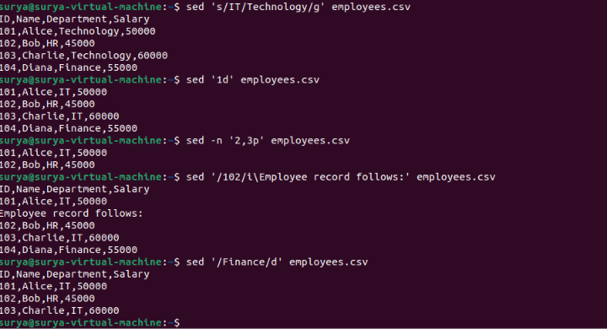

Validation Steps:

Run several commands from each group:
awk -F',' 'NR>1 {print $2, $4}' employees.csv
awk -F',' 'NR>1 {sum+=$4} END {print sum}' employees.csv
sed '1d' employees.csv
sed -n '2,3p' employees.csv

Verify that each command produces the expected output and that the original CSV file remains unchanged.

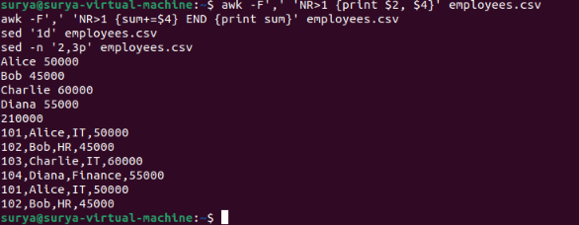

Explanation:

awk Select columns and fields
awk Filter records by conditions
awk Calculate totals and averages
awk Transform text fields
awk Format structured output
sed Substitute text
sed Delete selected lines
sed Print selected line ranges
sed Insert or append text
sed Filter lines by pattern

Real-Time Use Case:

System administrators use awk to analyze logs and structured reports, calculate statistics, and extract fields. They use sed to modify configuration templates, replace text, and filter lines in scripts or reports.

Common Errors and Troubleshooting:

Error | Solution
Wrong column is printed | Check the field separator and column number
Calculations are incorrect | Exclude headers and verify that the selected column is numeric
Replacement affects unexpected text | Use a more specific pattern
Original file changes unexpectedly | Print to the terminal or redirect output to a separate file
CSV parsing fails on quoted commas | Use a CSV-aware parser for files with complex quoting

